**ENGLISH**

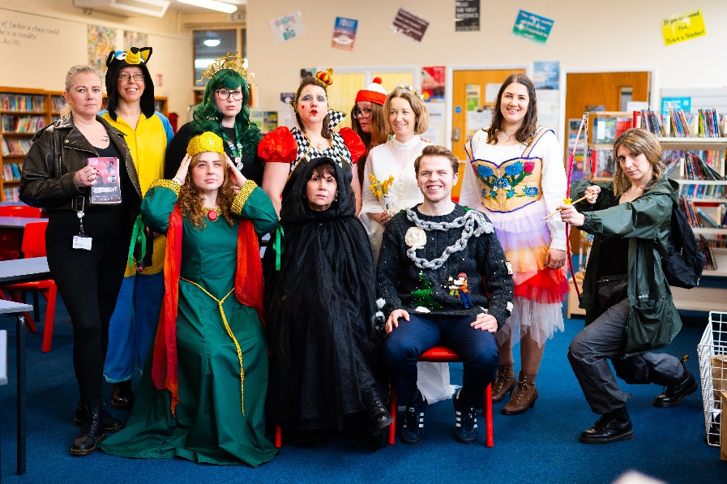

***World Book Day 2024***

Dear Year 6,

We are the English Faculty, based in Holkham. We are a big team, as you will see across the next couple of pages. We are passionate about reading; with this in mind, we have taken the opportunity to recommend a book to you.

In this booklet, you will find your summer task. Please complete this ready for September; you should bring it in on your first day and you will be told then who to hand it in to.

Across Year 7, you will enjoy reading some fantastic texts. As well as this, we will be working hard on developing the reading and writing skills you already have. There is so much joy to be had in exploring texts together, and we are looking forward to sharing this experience with you.

Have a good summer!

**The English Faculty**

**Your Summer Task**

The English teachers at Springwood want you to love reading as much as we do!

Over the summer, we want you to read a book of your choice. Here is a link to a list of recommended books suitable for Year 7 <https://schoolreadinglist.co.uk/reading-lists-for-ks3-pupils/suggested-reading-list-for-year-7-pupils-ks2-age-11-12/> but you may choose something that is not on this list (you may even wish to choose one of the books we have recommended on the previous pages).

When you have read your book, we would like you to write a postcard to your new English teacher (we have provided you with one that you can use). In your writing, please include answers to the following questions:

1. What do you think is the main idea that the writer is trying to get across in your chosen book?
2. What has led you to think that this is the main idea?

By answering these questions, you will be identifying the key theme of the text. As long as you give good reasons to explain your thinking, you cannot be wrong.

On the front side of the postcard, you could either draw a picture; print out and stick on a photo of the book’s front cover; or take a selfie with your book, print it and stick this on.

Please bring in your completed postcard on your first day of school in September.

Here is a model piece of writing to show you what we’re looking for.

***Appropriate salutation (greeting)***

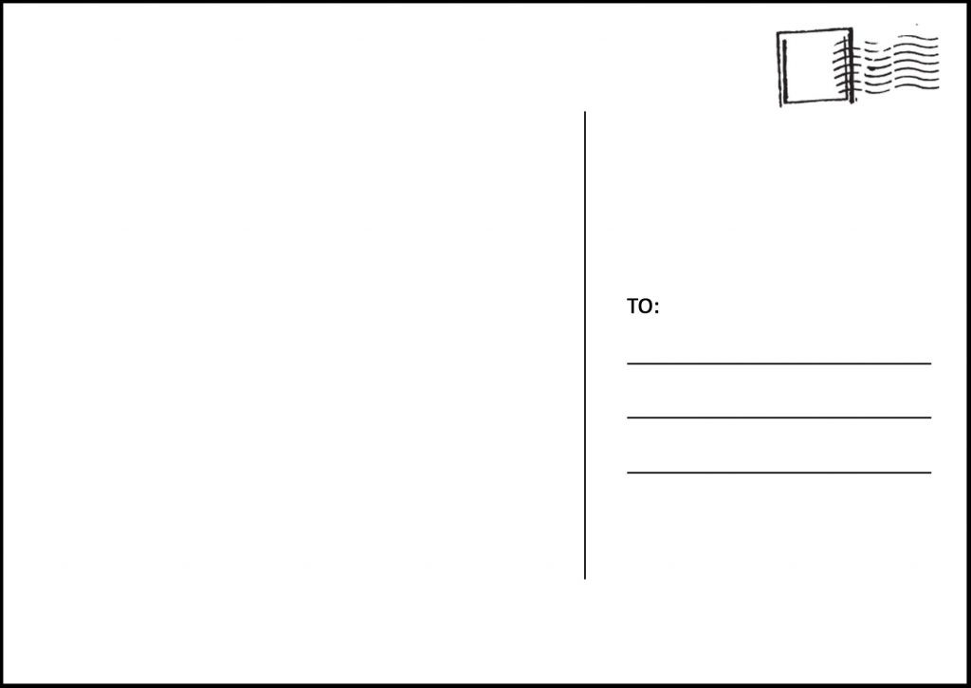

***Recommendation to the reader***

***Friendly sign-off***

Dear English Teacher,

I hope you have had a good summer! Did you do anything exciting?

I chose to read ‘Private Peaceful’ by Michael Morpurgo this summer. In my opinion, the main idea of this book is that it’s important to be brave and stand up for what is right. This is shown through the character of Charlie, who challenges the boys who bully Tommo and, later, won’t follow Sergeant Hanley’s cruel and ridiculous orders. At the end of the book, Charlie is court martialled and sentenced to death for “cowardice” because he disobeyed Sergeant Hanley, who was instructing the men to carry out a mission that would lead them to be killed instantly. At his execution, Charlie dies with honour because he knows he did the right thing in refusing Sergeant Hanley.

If you haven’t read this book already, I’d really recommend it!

See you in September!  
Regards, Oliver Twist

Holkham

Springwood High School

My English Teacher

***Stating the main idea (personal opinion) and reasons why you think this is the main idea***

***Naming the book***

***Friendly opener, directed at your reader***

My English Teacher

Holkham Corridor

Springwood High School

***Friendly sign off***

***Recommendation to the reader***

***Why this idea is important (using tentative language, e.g. might, could)***

We look forward to receiving lots of lovely postcards!