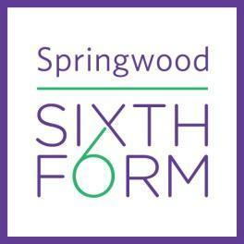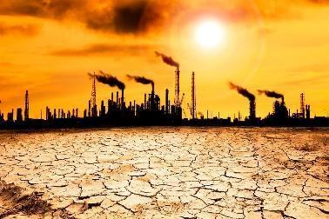

**Geography Summer Task Year 12**

| **Summer task – compulsory**  Create an academic poster based on fieldwork exploration of your/a local area.  **‘Place’ is one of the most important terms used by geographers and A-level Geography starts with a study of place and how places are changing. As part of the course, one of your units is Diverse Places. This task is designed to get you thinking about Diverse Places and prepare you for fieldwork tasks.**  Please read the accompanying detailed guidance sheet on how to complete the 4 steps of this summer task:  ***Step 1***: Read the information about the six different areas you can complete research on and how wide an area you should consider when we say ‘local’ – you need to choose three areas to focus on  ***Step 2***: Complete the fieldwork research sheet by completing primary and secondary research. The detailed guidance sheet will give you advice and links on this.  ***Step 3***: Using this information, create an academic poster to showcase to others. This can be on A3 paper or on one powerpoint slide/Google Slides which you should print as A3 size – A4 will be too difficult to see. There is an example in the detailed guidance sheet to refer to. Ensure you have included references, a word count, maps, graphs, annotated photos. Please refer to the marking criteria in the detailed guidance sheet to ensure you have covered all required areas.  ***Step 4***: Reflect on this process by completing the form at the end of the detailed guidance sheet.  **Summer task – optional stretch task**  Answer the question, in no more than 1500 words: *Is it still possible to limit global warming to 1.5°C?*  You must use at least 10 sources of reliable and credible information to help complete this essay.  You may want to consider:   * Recent COP events (particularly COP26, where the 1.5°C target was set) * What are the opportunities and challenges countries face when striving towards reducing GW? * What actions have been taken by different countries, including LICs, NEEs, HICs – is there any geopolitics involved here? Information specifically about what the UK is doing to reach its targets * What are the consequences of 1.5°C warming? Who, what, why, when, where, how – effects? * What are the consequences if warming is higher than 1.5°C? Who, what, why, when, where, how? Why does this matter?   **WARNING: Artificial Intelligence (AI) platforms should NOT be used to create any of your work. We are able to spot where work has been completed using AI and if this occurs, will result in very serious implications in your first week at Springwood Sixth Form. This would include undertaking of additional tasks, meetings with parents, withdrawal of privileges.**  **Suggested Visits**  Centre for Alternative Technology, Wales  Thames Barrier, London  Natural History Museum, London  Eden Project, Cornwall  Spend time in your local urban, rural, and coastal environments. Take lots of photos. What do you notice? Is there anything that intrigues you that you want to know more about? |
| --- |
| **Suggested Additional Reading**   * Disaster by Choice ~ Ilan Kelman * Prisoners of Geography ~ Tim Marshall * Geopolitics for the End Time: From the pandemic to the climate crisis ~ Bruno Macaes * The Decade we could have Stopped Climate Change ~ Nathaniel Rich * The Great Melt ~ Alister Doyle * The Sixth Extinction ~ Elizabeth Kolbert * No One is Too Small to Make a Difference ~ Greta Thunberg |
| **Equipment required for the course**   * A4 folders for notes * Scientific calculator (not on phone) * Sufficient time available in the summer between yr12 and yr13 to complete independent data collection for Fieldwork Dissertation |

**Submit your academic poster and reflection sheet, as well as any other work you have done in the first week of year 12.**

**You will be assessed on your suitability for the course based on this work.**