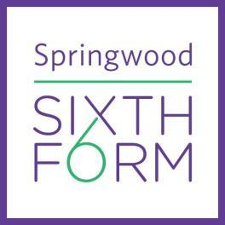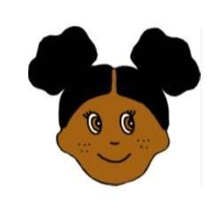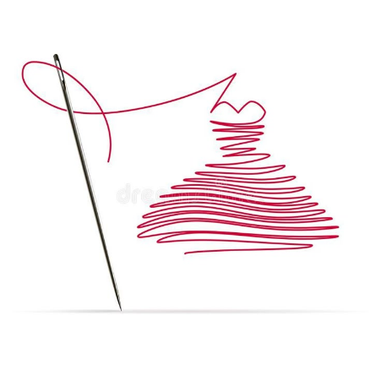

| **Optional extension**  We would like to challenge you to explore and develop your **practical skills** in Textiles.  **Instructions:**  **Hand Embroidery Sample (Optional):**   * Create a **hand embroidery sample** using a variety of stitches such as running stitch, backstitch, French knots, etc. Inspired by one of Vincent Van Gogh’s artworks. * If you are new to sewing check out my YouTube channel [**Makewell with Miss Markwell**](https://www.youtube.com/watch?v=iuz2hDe1FVY&list=PL9lHhz6KzQgryiB4D2QXkAXyaDk4b6FJB&pp=gAQB) for instructional videos. * Equipment: sewing needles, embroidery threads, embroidery hoops (optional), scrap material to sew onto (cotton, felt, old clothes, pillow cases, etc.).   **Summer Task Two Examples:** |
| --- |