Independent Research Project

A Level German



Name: _____________

**What is the IRP?**

* One element of the speaking exam
* The aim is to develop research skills (sources should be in German and a different range, including the internet

**Choosing a topic**

* Topic must focus on an aspect of a German speaking country
* It cannot be a topic you have already covered
* Choose something you are interested in
* It must be something you can give your opinion on and we can have a debate about

**Example Research Projects from AQA for German include:**

* A Film (Not Goodbye Lenin!)
* A literary work (Not Der Vorleser)
* An historical event/period/character
  + ‘Berlin am 13. August 1961’, ‘Der Reichstag
* An historical building
  + Der Reichstag
  + Brandenburger Tor
* A political figure
  + Angela Merkel- The role of Angela Merkel in modern Germany
  + Willy Brandt
* A writer/artist/singer/group/movement
  + Bertolt Brecht
  + Goethe
* An issue
  + Tierrecht in Deutschland
  + Einwanderung in der Schweiz
  + What is Germany’s energy policy and how effective is it in tackling climate change?
  + Gender equality in Germany
  + What has been the contribution of Turkish Gastarbeiter to German society?
  + The importance of tourism to the Austrian economy: successes and challenges
* A case study
  + Das Phänomen Aldi und Lidl
  + Volkswagen
  + BMW
  + What does the car industry contribute to the German economy? An analysis of past achievements and current challenges.
* A region/city/river
  + Munich
  + Berlin- The development of post-war Berlin
* A contrast
  + Die Ausbildung zum Dolmetscher/Lehrer/Arzt in Deutschland und Großbritannien
  + Bundesliga v Premier league
  + Education system
  + Deutsche und englische Mode
* A topic related to a personal interest
  + Deutsche Computerspiele

**Sources**

* Sources should be in German
* Use a variety of different sources (internet, books, magazines, newspapers, YouTube, Film, radio, podcasts, etc.)
* A minimum of 2 sources need to be used and a maximum of 10 (one must be an internet source). These should be presented to the examiner before the assessment with headings for what you are covering

**The Assessment**

* The speaking assessment will include preparation time, a discussion of the stimulus card, a two minute presentation of your IRP and then a discussion on your project with the examiner
* The two minute presentation should cover some key findings of the research and you must mention your two main references in German (marks for quality not quantity here!)
* The discussion will put an emphasis on:
  + eliciting views, opinions, ideas, and reactions from the student which the latter will be invited to explain, develop further, justify, illustrate, and defend, and where knowledge of the topic area will be paramount in supporting the responses given.
  + The discussion will focus on key concepts such as importance, impact, value, contribution, significance, as well as on the student’s appreciation of the topic area – its appeal and interest, and the insights the study has brought to the student.
  + This will naturally generate opportunities for the student to analyse and evaluate critically those aspects of the topic area that have been researched and will invite conclusions to be drawn.”
* An “excellent level of performance “ during the discussion is defined as:
  + The student will respond readily to all opportunities to explain, develop further, justify and defend opinions and views expressed about the topic under discussion.
  + Response to questions inviting the student to evaluate critically aspects of what has been researched will be supported by relevant factual knowledge.
  + Knowledge of the topic under discussion will be used consistently and effectively to support views and opinions.
  + Challenges from the examiner that perhaps call into question the validity of the student’s findings or the conclusions they are offering will consistently be responded to with a confident and effective marshalling of knowledge.

**Mark Scheme**

**Presentation**

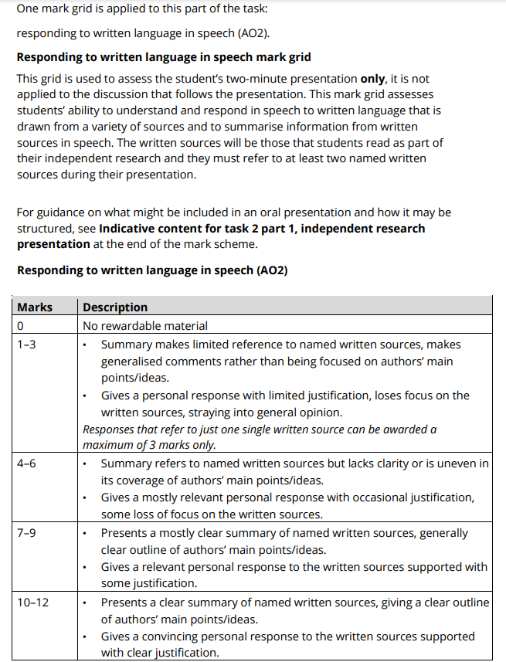

**Discussion of individual research project**

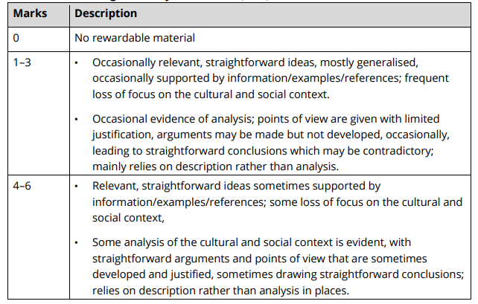

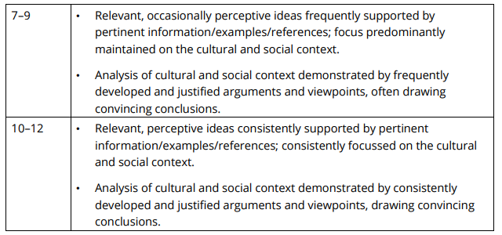

**Discussion of individual research project-**

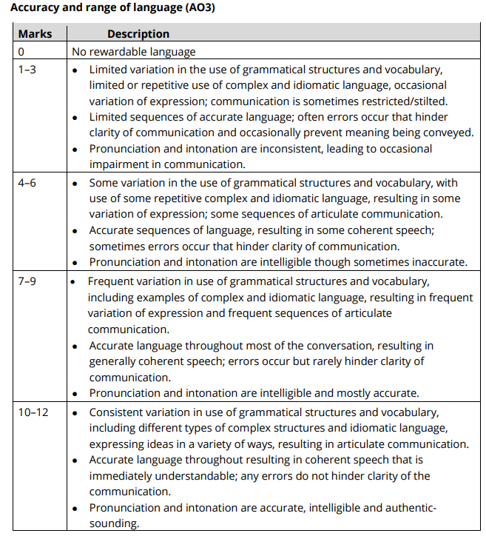

**Discussion of individual research project- Interaction**

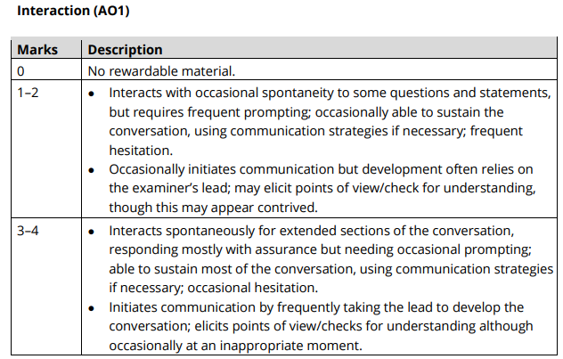

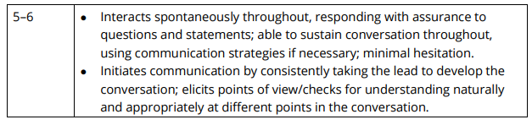

**Useful websites**

* ZDF Zoom- <https://www.zdf.de/dokumentation/zdfzoom>
* Spiegel- <https://www.spiegel.de/>
* Goethe-Institut- <https://www.goethe.de/en/index.html>
* Deutsche Welle- <https://www.dw.com/en/top-stories/s-9097>

**IRP INITIAL RESEARCH**

**1. Topic area:**

**2. Key resources:**

**3. Identify specific questions for the question words below you will be able to answer at the END of your research to ensure you achieve marks for ANALYSIS:**

**a) Was**

**b) Wo (MUST be related to German-speaking country)**

**c) Wer**

**d) Wann – including past and present situations**

**e) Wieviele (mit Statistiken)**

**f) Warum / Aus welchem Grund**

**g) Welche Folgen gibt es**

**h) Wie erfolgreich/bedeutend**

**i) Zukunft**

**Checklist**

* **Select a topic**
  + What interests me most?
  + Background reading in German and English
  + Make a list of possible topics and discuss with your teacher which is the most suitable
* **Suitability of topic**
  + Is my topic relevant to the target language country?
  + Can I access appropriate resources?
  + Does the topic allow me to develop interesting information, analysis, ideas and opinions?
* **Choosing sources and gathering information**
  + Gather all research in one place
  + Have I found and printed any internet sources?
  + Have I annotated resources?
  + Have I looked or asked about any resources at school?
  + Have I used any audio or video sources?
  + Have I noted key points and vocabulary?
  + Have I noted any key facts, statistics or quotes that I can cite?
  + Have I kept a list of references which I can refer to?
* **Organisation of ideas**
  + What will I include in my 2 minute presentation? (INCLUDING 2 SOURCES IN GERMAN)
  + Have I highlighted any questions I might be asked in the follow-up discussion in relation to the headings provided? Have I prepared answers to these headings?
  + You must give the examiner a list of a maximum of ten headings showing the outline of your presentation/research
  + I have handed in a form which shows a maximum of 10 headings (bullet points), showing the outline of your presentation/research for the examiner..
  + Are my headings for the examiner clear?
* **Answering questions during the discussion**
  + Do I have enough knowledge on the topic?
  + Can I precisely quote my sources?
  + Have I focused on analysis and evaluation of information and not just description?
  + Am I prepared to answer any counter arguments?
  + Do I have the language to maintain the discussion?
  + Am I prepared to include advanced grammatical structures and idioms?
* **Revision**
  + Have I practiced with someone?
  + Have I recorded myself speaking to check for speed, clarity, pronunciation and intonation?