**Compulsory (all must be completed)**

Task 1:

1. Create a diagram of a neuron (you may be creative as you like) and label each part, including the function of that part:  
     
   *Cell body (soma), axon, myelin sheath, nodes of ranvier, dendrites, terminal buttons.*
2. Create a diagram of the brain (you may be as creative as you like) and label each part, including the function of that part:

*Broca’s area, Wernicke’s area, the motor cortex, the somatosensory cortex, the cerebellum, the brain stem, the prefrontal cortex, the hippocampus, the thalamus and the amygdala.*

Task 2:

Answer the following questions about each of the key Psychologists listed below.

Philip Zimbardo

1. What was the area of Psychology Zimbardo studied?
2. Briefly outline the procedure and findings of the Stanford Prison Experiment.
3. Why was Zimbardo’s experiment seen as being so controversial?
4. What is the Abu Ghraib scandal and how does this relate to Zimbardo’s work?

Sigmund Freud

1. What was the area of Psychology Freud studied?
2. Briefly outline how Freud’s Psychoanalysis is used as a treatment for mental illness.
3. Briefly explain how Freudian psychology explains a behaviour of your choice, for example, depression, anxiety, offending, sexuality, or relationships.

BF Skinner

1. What was the area of Psychology Skinner studied?
2. Briefly outline Skinner’s concept of operant conditioning.
3. Where do you think Skinner’s theory could be applied in everyday life?
4. Briefly summarise what Behaviourism is within Psychology.

Task 3:

Create a fact file on a psychiatric illness of your choice. For example, depression, anxiety, OCD, schizophrenia, or absolutely anything you are interested in. Be as creative as you like… you could include images and colour or present your information in a poster/leaflet style format. It is up to you.

In your fact file, try to include:

*1. Symptoms and overview of the illness*

*2. One or more explanations for why people suffer from this illness*

*3. Treatments that are available for this illness*

*4. Any other interesting or useful information you find*

Task 4:

Study the graph below.

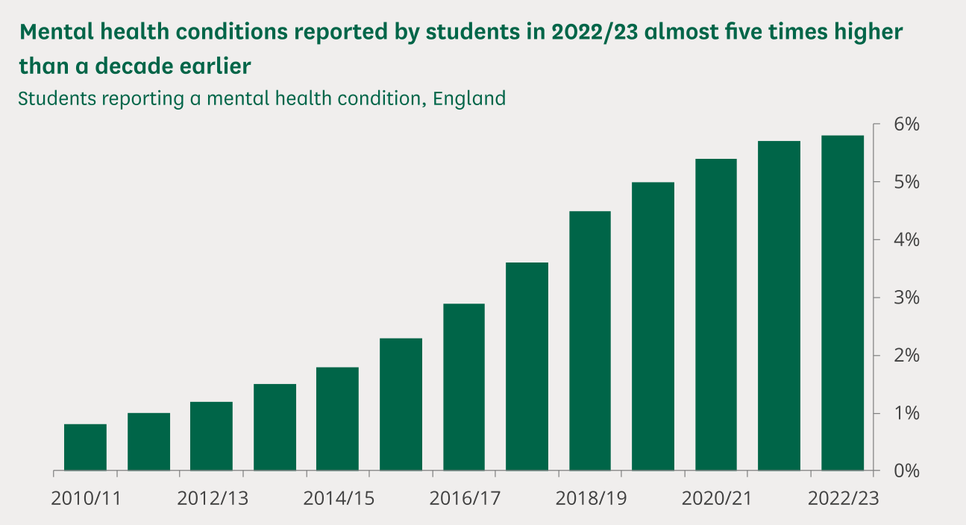

In approximately 500 words, outline what you think is the cause(s) of the trend shown. You might discuss more than one cause. This will require you to think critically, conduct some research, and ask yourself questions about the rising epidemic of mental illness in the UK. There really is no right or wrong answer; we are just interested in **your views and explanations of this trend.** NB: *While you may use AI tools to conduct research, please avoid using it to write your final piece - it will be very obvious, and diminishes the “critical thinking” aspect of the task.*

**Optional extra task**

Write a review of one (or more!) of the following books or documentaries/films. Some structure to help your review:

1. Why you chose it

2. What was your prior knowledge of the topic, if any?

3. What was it about?

4. Did you enjoy it, why/why not?

5. What would you like to find out more about afterwards?

6. Any other relevant information

**Books:**

“Obedience to Authority" – *Stanley Milgram*Foundational reading on obedience and ethics in psychological research.

"The Man Who Mistook His Wife for a Hat" – *Oliver Sacks*Fascinating neurological case studies relevant to cognitive psychology.

"Opening Skinner’s Box" – *Lauren Slater*Explores 10 famous psychology experiments with context and analysis.

"Thinking, Fast and Slow" – *Daniel Kahneman*Insight into cognitive psychology, biases, and decision-making.

"The Psychopath Test" – *Jon Ronson*Engaging, accessible book exploring abnormal psychology and mental health.

"Mindwatching: Why We Behave the Way We Do" – *Hans and Michael Eysenck*An overview of many psychological concepts from a historical perspective.

"The Lucifer Effect" – *Philip Zimbardo*

A deep dive into the Stanford Prison Experiment and the psychology of evil.

"We Need to Talk About Kevin" *– Lionel Shriver*Raises issues related to nature vs nurture, aggression, and parenting.

“Prozac Nation” - *Elizabeth Wurtzel*Raises issues surrounding the diagnosis and treatment of disorders such as depression and anxiety.  
  
"Flowers for Algernon" *– Daniel Keyes*Explores intelligence and ethics in psychological experimentation.

**Documentaries/films:**

Anything by Derren Brown - YouTube/Channel 4 on Demand

Stacey Dooley: On the Psych Ward - BBC iPlayer

The Mind Explained - Netflix

I Am a Killer - Netflix

The…. Tapes (Bundy, Dahmer, Gacy etc.) - Netflix

The Confession Tapes - Netflix

Take Your Pills - Netflix

Stutz - Netflix

The Social Dilemma - Netflix

Babies - Netflix

**Other:**

If you enjoy podcasts, we recommend:

All in the Mind (BBC Sounds) <https://www.bbc.co.uk/programmes/b006qxx9/episodes/downloads>

Speaking of Psychology (APA) <https://www.apa.org/news/podcasts/speaking-of-psychology>

We would also recommend you subscribe to the American Psychological Association’s newsletter “Six Things Psychologists are Talking About” - <https://www.apa.org/monitor/six-things>. You can download the APA monitor app from your app store for digital copies and Psychology on the go!