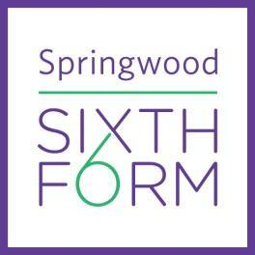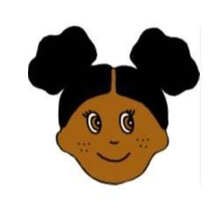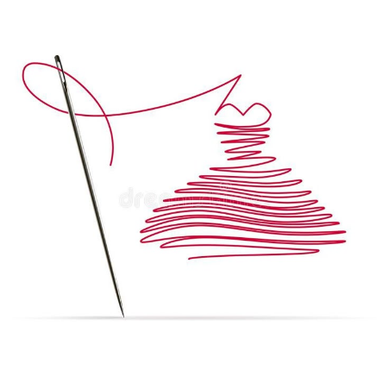

| **Additional Instructions/ Reading/ Videos:**  **Suggested Visit:** A gallery visits - to either a local, national gallery or museum.  **How to sew YouTube channels:**  [**https://www.youtube.com/c/MakewellwithMissMarkwell/videos**](https://www.youtube.com/c/MakewellwithMissMarkwell/videos)  [**https://www.youtube.com/user/ProfessorPincushion**](https://www.youtube.com/user/ProfessorPincushion)  [**https://www.youtube.com/user/MaryCorbet**](https://www.youtube.com/user/MaryCorbet)  **How to design fashion Illustrations:**  [**How to become a Fashion Designer - zoehongteaches**](https://www.youtube.com/@zoehongteaches)  **Art practitioners/ museums/ galleries/ channels:**  [Vincent Van Gogh](https://www.youtube.com/watch?v=3q5fuVFWe0Q)  [Tate Modern](https://www.tate.org.uk/?authuser=1)  [Saatchi Gallery](https://www.saatchigallery.com/?authuser=1)  [V&A Museum](https://www.vam.ac.uk/?srsltid=AfmBOopruZSTnQ_oCNHFBAF-2FGuvawpDiKPONJapWCLkLIMbvn8pHTY)  [Jim Henson](https://www.henson.com/?authuser=1)  [Vivenne Westwood](https://www.viviennewestwood.com/en-gb/homepage/?gad_source=1&gad_campaignid=231123755&gbraid=0AAAAADYSJ9cT4DYvwtpIicvugBqckZpm-&gclid=Cj0KCQjw_JzABhC2ARIsAPe3ynoVPRG1yPUWywReo2DrjQLm3trZSMFaRGqyL1vY-pgWFqSqxvrd7IwaAloXEALw_wcB&gclsrc=aw.ds)  [London Museum](https://www.londonmuseum.org.uk/collections/london-stories/how-mary-quant-revolutionised-1960s-fashion/)  [Alexandre McQueen](https://www.alexandermcqueen.com/en-gb)  **Follow: Makewell with Miss Markwell** on all her Social Media account -: Click on the logo links:  [**My TikTok account**](https://www.tiktok.com/@missmarkwell) **– I follow lots of creative practitioners, might be worth a look…always good to be inspired by other peoples’ work.** |
| --- |