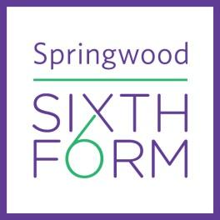

**Summer Tasks**

**So, you think you would like to study: Economics**

| **Compulsory tasks**  **Task 1**  Macro Economics Summer Task Brief:  Springwood Sixth Form has formed its own advisory organisation called “The Springforwards.” You have been asked to **write a report** to the government outlining the strategies you recommend they use to help the economy grow without further affects on inflation.  Think About:   * What strategies are the current political party in power using currently to encourage the UK economy to grow (with examples)? * Why have they been adopted and how should they work? Who are they aimed at? How can they measure their effectiveness? – minimum of 3  1. Monetary policy 2. Fiscal policy 3. Supply Side policies  * How your strategies will help stimulate the economy (refer to macro-economic objectives- below). You should use data to show the current position of these objectives below and how they vary from the government targets.   + Employment   + Economic Growth   + Inflation   + Balance of Payments   + Distribution of Income * Why you believe other strategies are unhelpful * How your policies may cause macroeconomic conflicts- the economic problem-which is the most important policy & why   (Two sides of A4)  **TASK 2**  Micro Economics Summer Task Brief:  (One side of A4)   * Research a market where there are either supply or demand issues? What is the problem? Who is it affecting? Describe the situation. (POWER/TRAINS/WATER) * What would “free market” economists suggest happens to correct this problem? * What would a “government intervention” approach suggest happens to correct the problem?- explain at least 3 ways   **Optional extension task**  Task 1: Create a handout on the following:  Famous Economists worth knowing   * Find out why these economists are famous? * What is their work/theory well known for?  1. John Maynard Keynes 2. Milton Freidman 3. Adam Smith 4. David Ricardo 5. Freidrich Hayek   Task 2: Try to visit any of the following;  High street banks  Bank of England  Local council  **We will be looking for fully extended, well researched and explained points.** |
| --- |
|  |
| **Suggested Additional Reading:**  See separate document |

**Please submit the task, as well as a copy of the reading log, to your teacher on the first lesson in September. Feel to do multiple summer tasks if you are unsure on what subjects to study.**