**Year 12 to 13 Summer Task – Exam Question Pack (12DB1)**

**3.1.3 Lipids**

**Q1.**

The diagram represents a triglyceride.

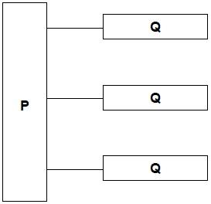

(a)     Name the molecules represented in the diagram by:

Box **P** _____________________________________________________________

Box **Q** _____________________________________________________________

**(2)**

(b)     Name the type of bond between **P** and **Q** in the diagram.

___________________________________________________________________

**(1)**

(c)     Describe how you would test a liquid sample for the presence of lipid **and** how you would recognise a positive result.

___________________________________________________________________

___________________________________________________________________

___________________________________________________________________

___________________________________________________________________

___________________________________________________________________

___________________________________________________________________

___________________________________________________________________

___________________________________________________________________

___________________________________________________________________

___________________________________________________________________

**(2)**

**(Total 5 marks)**

**Q2.**

(a)     **Figure 1** shows the structure of a molecule of glycerol and a molecule of fatty acid.

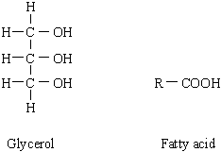

**Figure 1**

Draw a diagram to show the structure of a triglyceride molecule.

**(2)**

(b)     Explain why triglycerides are **not** considered to be polymers.

___________________________________________________________________

___________________________________________________________________

**(1)**

(c)     **Figure 2** shows two types of fat storage cell. Mammals living in cold conditions have more brown fat cells than mammals living in tropical conditions.

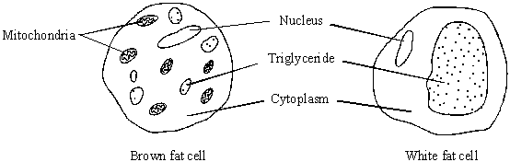

**Figure 2**

Using evidence from **Figure 2** to support your answer, suggest how the function of brown fat cells differs from that of white fat cells.

___________________________________________________________________

___________________________________________________________________

___________________________________________________________________

___________________________________________________________________

___________________________________________________________________

___________________________________________________________________

**(3)**

**(Total 6 marks)**

**Q3.**

(a)     Describe the difference between the structure of a triglyceride molecule and the structure of a phospholipid molecule.

___________________________________________________________________

___________________________________________________________________

___________________________________________________________________

**(1)**

(b)     Describe how you would test for the presence of a lipid in a sample of food.

___________________________________________________________________

___________________________________________________________________

___________________________________________________________________

___________________________________________________________________

**(2)**

(c)     Animal fats contain triglycerides with a high proportion of saturated fatty acids. If people have too much fat in their diet, absorption of the products of fat digestion can increase the risk of obesity. To help people lose weight, fat substitutes can be used to replace triglycerides in food.

Describe how a saturated fatty acid is different from an unsaturated fatty acid.

___________________________________________________________________

___________________________________________________________________

___________________________________________________________________

**(1)**

The diagram shows the structure of a fat substitute.

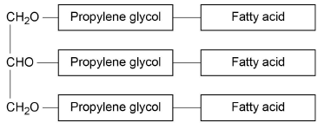

(d)     This fat substitute **cannot** be digested in the gut by lipase.

Suggest why.

___________________________________________________________________

___________________________________________________________________

___________________________________________________________________

___________________________________________________________________

___________________________________________________________________

**(2)**

(e)     This fat substitute is a lipid. Despite being a lipid, it cannot cross the cell-surface membranes of cells lining the gut.

Suggest why it **cannot** cross cell-surface membranes.

___________________________________________________________________

___________________________________________________________________

___________________________________________________________________

**(1)**

**(Total 7 marks)**

**Q4.**

(a)     Some seeds contain lipids. Describe how you could use the emulsion test to show that a seed contains lipids.

___________________________________________________________________

___________________________________________________________________

___________________________________________________________________

___________________________________________________________________

___________________________________________________________________

___________________________________________________________________

___________________________________________________________________

**(3)**

(b)     A triglyceride is one type of lipid. The diagram shows the structure of a triglyceride molecule.

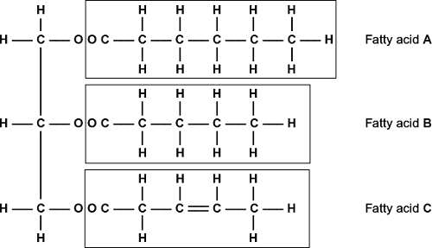

(i)      A triglyceride molecule is formed by condensation. From how many molecules is this triglyceride formed?



**(1)**

(ii)     The structure of a phospholipid molecule is different from that of a triglyceride.  
Describe how a phospholipid is different.

______________________________________________________________

______________________________________________________________

______________________________________________________________

______________________________________________________________

______________________________________________________________

**(2)**

(iii)    Use the diagram to explain what is meant by an unsaturated fatty acid.

______________________________________________________________

______________________________________________________________

______________________________________________________________

______________________________________________________________

**(2)**

**(Total 8 marks)**

**3.1.4.1 General properties of proteins**

**Q1.**

Amino acids are used to make proteins. **Table 1** shows the R groups of six different amino acids.

| **Table 1** | | | | |
| --- | --- | --- | --- | --- |
| **Amino acid** | **R group** |  | **Amino acid** | **R group** |
| Alanine | CH3 |  | Glutamic acid | CH2CH2COOH |
| Asparagine | CH2CONH2 |  | Glycine | H |
| Aspartic acid | CH2COOH |  | Serine | CH2OH |

(a)  Use **Table 1** to identify the **three** different amino acids used to make the polypeptide shown in **Figure 1**.

**Figure 1**

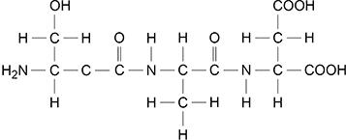

Left amino acid  _____________________________________________________

Middle amino acid  ___________________________________________________

Right amino acid  ____________________________________________________

**(2)**

(b)  **Table 2** shows three statements and names of four biological molecules.

Put a Tick (**✓**) in each box where the statement is true for the biological molecule.

| **Table 2** | | | | |
| --- | --- | --- | --- | --- |
| **Statement** | **DNA** | **ATP** | **Reverse transcriptase** | **Phospholipid** |
| Contains peptide bonds |  |  |  |  |
| Is formed using a condensation reaction |  |  |  |  |
| Is a polymer |  |  |  |  |

**(3)**

**Figure 2** represents the structure of adult human haemoglobin.

**Figure 2**

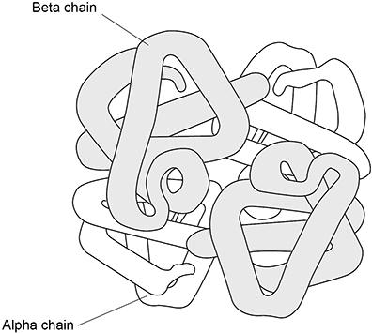

(c)  The number of amino acids in the beta chains in **Figure 2** is 3.546% greater than in the alpha chains. Each alpha chain contains 141 amino acids.

Calculate how many amino acids there are in total in the haemoglobin molecule shown in **Figure 2**. Give your answer to the nearest whole number.

Answer _______________ amino acids

**(2)**

**(Total 7 marks)**

**Q2.**

The diagram shows the structure of the amino acid serine.

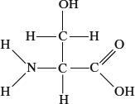

(a)     (i)      Draw a box on the diagram around the R group of serine and label the box with the letter **R**.

**(1)**

(ii)     Draw a circle around each of the parts of the serine molecule which would be removed when **two** other amino acid molecules join directly to it.

**(1)**

(b)     (i)      Which **two** substances are formed when two amino acid molecules join together?

1. ____________________________________________________________

2. ____________________________________________________________

**(1)**

(ii)     Name the type of bond formed between the joined pair of amino acid molecules.

______________________________________________________________

**(1)**

(c)     Explain how a change in the primary structure of a globular protein may result in a different three-dimensional structure.

___________________________________________________________________

___________________________________________________________________

___________________________________________________________________

___________________________________________________________________

___________________________________________________________________

___________________________________________________________________

**(3)**

**(Total 7 marks)**

**Q3.**

(a)     Describe how you would use a biochemical test to show that a solution contained protein.

___________________________________________________________________

___________________________________________________________________

___________________________________________________________________

___________________________________________________________________

**(2)**

The diagram shows the structure of two amino acid molecules, tyrosine and phenylalanine.

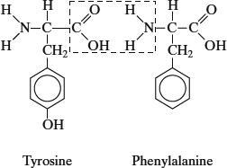

(b)     Copy from the diagram the R group in the phenylalanine molecule.

**(1)**

(c)     (i)      In the space below, draw the chemical bond formed when these two amino acids are joined by condensation. You need only draw the parts of the molecules shown in the box.

**(2)**

(ii)     Name this bond.

______________________________________________________________

**(1)**

(d)     Tyrosine can be made in the body by hydroxylating phenylalanine. Use the diagram to explain the meaning of *hydroxylating*.

___________________________________________________________________

___________________________________________________________________

**(1)**

**(Total 7 marks)**

**3.1.5.2 DNA replication**

**Q1.**

**Figure 1** shows one base pair of a DNA molecule.

**Figure 1**

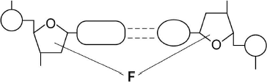

(a)     Name part **F** of each nucleotide.

___________________________________________________________________

**(1)**

(b)     Scientists determined that a sample of DNA contained 18% adenine.

What were the percentages of thymine and guanine in this sample of DNA?

| Percentage of thymine |  |
| --- | --- |
| Percentage of guanine |  |

**(2)**

During replication, the two strands of a DNA molecule separate and each acts as a template for the production of a new strand.

**Figure 2** represents DNA replication.

**Figure 2**

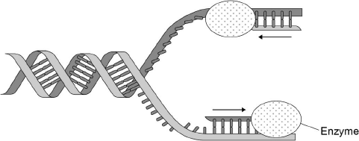

(c)     Name the enzyme shown in **Figure 2**.

___________________________________________________________________

**(1)**

The arrows in **Figure 2** show the directions in which each new DNA strand is being produced.

(d)     Use **Figure 1, Figure 2** and your knowledge of enzyme action to explain why the arrows point in opposite directions.

___________________________________________________________________

___________________________________________________________________

___________________________________________________________________

___________________________________________________________________

___________________________________________________________________

___________________________________________________________________

___________________________________________________________________

___________________________________________________________________

**(4)**

**(Total 8 marks)**

**Q2.**

The bases in DNA nucleotides contain nitrogen.

Researchers grew bacteria on a medium containing 15N (‘heavy’ nitrogen) for several generations. They then transferred the bacteria to a medium containing 14N (‘ordinary’ nitrogen). They analysed DNA from the bacteria at three stages:

1. whilst the bacteria were growing on the 15N medium

2. after one division of the bacteria on the 14N medium

3. after two divisions of the bacteria on the 14N medium

The diagram shows their results.

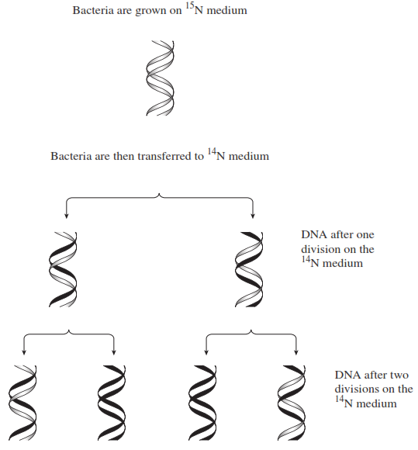

(a)     Describe how the proportion of DNA that contained 15N changed at each division when bacteria were grown on the 14N medium.

___________________________________________________________________

___________________________________________________________________

___________________________________________________________________

___________________________________________________________________

**(2)**

(b)     The change in the proportion of DNA containing 15N is due to the way in which DNA replicates. Explain how.

___________________________________________________________________

___________________________________________________________________

___________________________________________________________________

___________________________________________________________________

**(2)**

**(Total 4 marks)**

**Q3.**

(a)     Explain why the replication of DNA is described as semi-conservative.

___________________________________________________________________

___________________________________________________________________

___________________________________________________________________

___________________________________________________________________

**(2)**

(b)     Bacteria require a source of nitrogen to make the bases needed for DNA replication. In an investigation of DNA replication some bacteria were grown for many cell divisions in a medium containing 14N, a light form of nitrogen. Others were grown in a medium containing 15N, a heavy form of nitrogen. Some of the bacteria grown in a 15N medium were then transferred to a 14N medium and left to divide once.

DNA was isolated from the bacteria and centrifuged.

The DNA samples formed bands at different levels, as shown in the diagram.

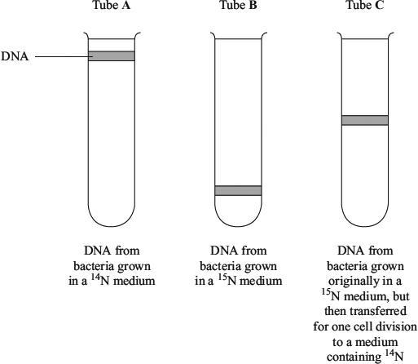

(i)      What do tubes **A** and **B** show about the density of the DNA formed using the two different forms of nitrogen?

______________________________________________________________

______________________________________________________________

**(1)**

(ii)     Explain the position of the band in tube **C**.

______________________________________________________________

______________________________________________________________

______________________________________________________________

______________________________________________________________

**(2)**

(c)     In a further investigation, the DNA of the bacterium was isolated and separated into single strands. The percentage of each nitrogenous base in each strand was found. The table shows some of the results.

|  | **Percentage of base present** | | | |
| --- | --- | --- | --- | --- |
| **DNA sample** | Adenine | Cytosine | Guanine | Thymine |
| Strand 1 | 26 |  | 28 | 14 |
| Strand 2 | 14 |  |  |  |

Use your knowledge of base pairing to complete the table.

**(2)**

**(Total 7 marks)**

**Q4.**

The diagram shows the process of DNA replication. The horizontal lines represent the positions of bases.

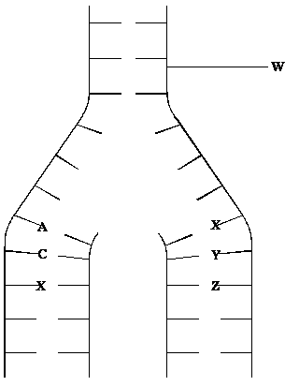

(i)      What is represented by the part of the DNA molecule labelled **W**?

___________________________________________________________________

**(1)**

(ii)      In the diagram, **A** represents adenine and **C** represents cytosine.

Name the base found at

position **X**; __________________________________________________________

position **Y**; __________________________________________________________

position **Z**. __________________________________________________________

**(3)**

**(Total 4 marks)**

**Q5.**

(a)    Describe how DNA is replicated.

___________________________________________________________________

___________________________________________________________________

___________________________________________________________________

___________________________________________________________________

___________________________________________________________________

___________________________________________________________________

___________________________________________________________________

___________________________________________________________________

___________________________________________________________________

___________________________________________________________________

___________________________________________________________________

___________________________________________________________________

**(6)**

**(Total 6 marks)**

**Q6.**

(a)     DNA helicase is important in DNA replication. Explain why.

___________________________________________________________________

___________________________________________________________________

___________________________________________________________________

___________________________________________________________________

___________________________________________________________________

**(2)**

Scientists investigating DNA replication grew bacteria for several generations in a nutrient solution containing a heavy form of nitrogen (15N). They obtained DNA from a sample of these bacteria.

The scientists then transferred the bacteria to a nutrient solution containing a light form of nitrogen (14N). The bacteria were allowed to grow and divide twice. After each division, DNA was obtained from a sample of bacteria.

The DNA from each sample of bacteria was suspended in a solution in separate tubes. These were spun in a centrifuge at the same speed and for the same time. The diagram shows the scientists’ results.

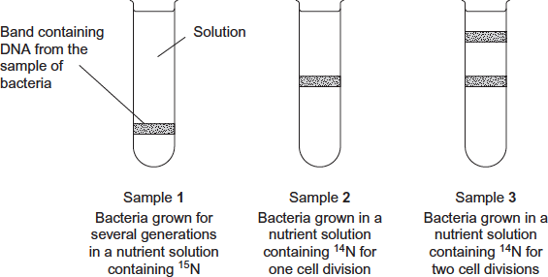

(b)     The table shows the types of DNA molecule that could be present in samples **1** to **3**.  
Use your knowledge of semi-conservative replication to complete the table with a tick if the DNA molecule is present in the sample.

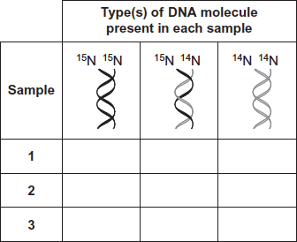

**(3)**

(c)     Cytarabine is a drug used to treat certain cancers. It prevents DNA replication. The diagram shows the structures of cytarabine and the DNA base cytosine.

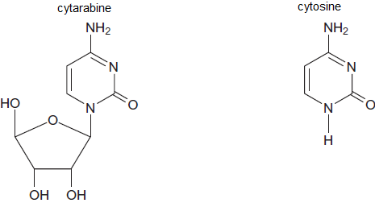

(i)      Use information in the diagram to suggest how cytarabine prevents DNA replication.

______________________________________________________________

______________________________________________________________

______________________________________________________________

______________________________________________________________

______________________________________________________________

**(2)**

(ii)     Cytarabine has a greater effect on cancer cells than on healthy cells. Explain why.

______________________________________________________________

______________________________________________________________

______________________________________________________________

**(1)**

**(Total 8 marks)**

**Q7.**

The following figure represents part of a DNA molecule.

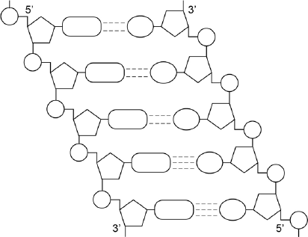

(a)     Draw a box around a single nucleotide.

**(1)**

The table below shows the percentage of bases in each of the strands of a DNA molecule.

| **DNA strand** | **Percentage of each base** | | | |
| --- | --- | --- | --- | --- |
| **A** | **C** | **G** | **T** |
| Strand **1** | 16 |  |  |  |
| Strand **2** |  | 21 | 34 |  |

(b)     Complete the table by adding the missing values.

**(2)**

(c)     During replication, the two DNA strands separate and each acts as a template for the production of a new strand. As new DNA strands are produced, nucleotides can only be added in the 5’ to 3’ direction.

Use the figure in part **(a)** and your knowledge of enzyme action and DNA replication to explain why new nucleotides can only be added in a 5’ to 3’ direction.

___________________________________________________________________

___________________________________________________________________

___________________________________________________________________

___________________________________________________________________

___________________________________________________________________

___________________________________________________________________

___________________________________________________________________

___________________________________________________________________

**(4)**

**(Total 7 marks)**

**3.1.6 ATP**

**Q1.**

Cells constantly hydrolyse ATP to provide energy.

(a)     Describe how ATP is resynthesised in cells.

___________________________________________________________________

___________________________________________________________________

___________________________________________________________________

___________________________________________________________________

**(2)**

(b)     Give **two** ways in which the hydrolysis of ATP is used in cells.

1. _________________________________________________________________

___________________________________________________________________

2. _________________________________________________________________

___________________________________________________________________

**(2)**

**(Total 4 marks)**

**Q2.**

(a)  Describe how an ATP molecule is formed from its component molecules.

___________________________________________________________________

___________________________________________________________________

___________________________________________________________________

___________________________________________________________________

___________________________________________________________________

___________________________________________________________________

___________________________________________________________________

___________________________________________________________________

___________________________________________________________________

**(4)**

**(Total 4 marks)**

**3.1.7 Water**

**Q1.**

(a)  Explain **five** properties that make water important for organisms.

___________________________________________________________________

___________________________________________________________________

___________________________________________________________________

___________________________________________________________________

___________________________________________________________________

___________________________________________________________________

___________________________________________________________________

___________________________________________________________________

___________________________________________________________________

___________________________________________________________________

___________________________________________________________________

___________________________________________________________________

**(5)**

(b)     State and explain the property of water that helps to prevent temperature increase in a cell.

Property  __________________________________________________________

Explanation  ________________________________________________________

___________________________________________________________________

___________________________________________________________________

___________________________________________________________________

**(2)**

**3.2.1.1 Structure of eukaryotic cells**

**Q1.**

(a)  Describe the structure and function of the nucleus.

___________________________________________________________________

___________________________________________________________________

___________________________________________________________________

___________________________________________________________________

___________________________________________________________________

___________________________________________________________________

___________________________________________________________________

___________________________________________________________________

___________________________________________________________________

___________________________________________________________________

___________________________________________________________________

___________________________________________________________________

**(4)**

(b)  Name the main polymer that forms the following cell walls.

Plant cell wall  ______________________________________________________

Fungal cell wall  _____________________________________________________

**(1)**

**(Total 5 marks)**

**Q2.**

The drawing shows part of a human cell.

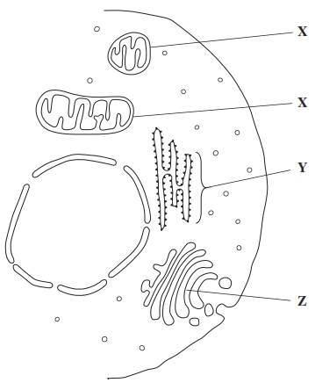

(a)     Name organelles

**X** _________________________________________________________________

**Y** _________________________________________________________________

**(2)**

(b)     (i)      The organelles labelled **X** all have very similar shapes in this cell.  
Explain why they appear to have different shapes in this drawing.

______________________________________________________________

______________________________________________________________

*(Extra space)* ___________________________________________________

______________________________________________________________

**(1)**

(ii)     Large numbers of organelles **X** and **Z** are found in mucus-secreting cells.  
Explain why.

______________________________________________________________

______________________________________________________________

______________________________________________________________

______________________________________________________________

*(Extra space)* ___________________________________________________

______________________________________________________________

**(2)**

**(Total 5 marks)**

**Q3.**

The drawing shows part of a plant cell as seen with an electron microscope.

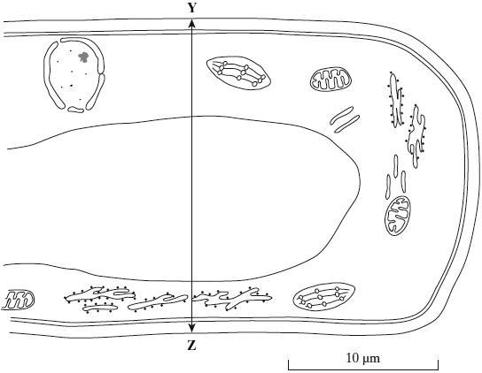

(i)      Give **two** features shown in the drawing which are evidence that this cell is eukaryotic.

1. _________________________________________________________________

___________________________________________________________________

2. _________________________________________________________________

___________________________________________________________________

**(2)**

(ii)     Calculate the actual width of the cell from **Y** to **Z**. Give your answer in micrometres (µm) and show your working.

Answer ____________________ µm

**(2)**

(iii)     Give **one** way in which a typical animal cell differs from the cell shown in the drawing.

___________________________________________________________________

___________________________________________________________________

**(1)**

**(Total 5 marks)**

**Q4.**

The electron micrograph shows part of a chloroplast.

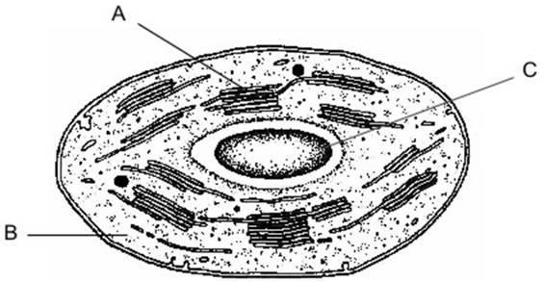

(a)     Name the parts labelled **A** and **B** and, for each, describe **one** role in the process of photosynthesis.

**A** Name ___________________________________________________________

Role ______________________________________________________________

**B** Name ___________________________________________________________

Role ______________________________________________________________

**(4)**

(b)     (i)      Name the main substance present in the part labelled **C**.

______________________________________________________________

**(1)**

(ii)     How is this substance formed?

______________________________________________________________

______________________________________________________________

**(1)**

**(Total 6 marks)**

**Q5.**

The diagram shows part of an animal cell as seen through an electron microscope.

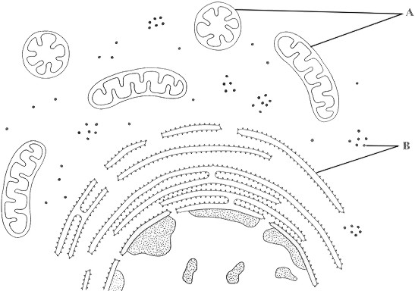

(a)     Name the organelles labelled **A** and **B**.

**A** _________________________________________________________________

**B** _________________________________________________________________

**(2)**

(b)     Explain why the shapes of the two organelles labelled **A** appear different.

___________________________________________________________________

___________________________________________________________________

___________________________________________________________________

___________________________________________________________________

**(2)**

(c)     Give the function of organelle **B**.

___________________________________________________________________

___________________________________________________________________

**(1)**

(d)     The epithelial cells of the small intestine have large numbers of organelle **A**.  
Explain how this is an adaptation for the function of these cells.

___________________________________________________________________

___________________________________________________________________

___________________________________________________________________

___________________________________________________________________

___________________________________________________________________

___________________________________________________________________

**(3)**

**(Total 8 marks)**

**3.2.1.2 Structure of prokaryotic cells and of viruses**

**Q1.**

(a)  The figure below is an image of a bacterium obtained using a scanning electron microscope.

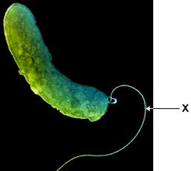

Name the structure labelled **X**.

___________________________________________________________________

**(1)**

(b)  The figure above is different from an image of this bacterium obtained using a transmission electron microscope.

Describe and explain **one** difference between these images.

Description  _________________________________________________________

___________________________________________________________________

Explanation  ________________________________________________________

___________________________________________________________________

**(2)**

(c)  The resolution of an image obtained using an electron microscope is higher than the resolution of an image obtained using an optical microscope.

Explain why.

___________________________________________________________________

___________________________________________________________________

___________________________________________________________________

**(1)**

(d)  A student determined the size of a cell structure from a photograph obtained using a microscope.

He used a ruler and a calculator and gave the answer in μm

Describe how the student determined the size of the structure.

___________________________________________________________________

___________________________________________________________________

___________________________________________________________________

___________________________________________________________________

**(2)**

(e)  Name **two** structures found in **all** bacteria that are **not** found in plant cells.

1  _________________________________________________________________

2  _________________________________________________________________

**(2)**

(f)  Name **two** features of HIV particles that are **not** found in bacteria.

Do **not** include attachment protein in your answer.

1  _________________________________________________________________

2  _________________________________________________________________

**(2)**

**(Total 10 marks)**

**Q2.**

The diagram shows the outer layers of three different cells, **A**, **B** and **C**.

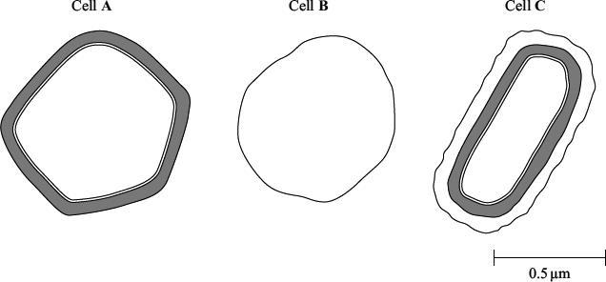

(a)     What is the evidence from the diagram that

(i)      cell **B** is an animal cell,

______________________________________________________________

______________________________________________________________

**(1)**

(ii)     cell **C** is a prokaryotic cell?

______________________________________________________________

______________________________________________________________

**(1)**

(b)     Explain how you would calculate the magnification of cell **C**.

___________________________________________________________________

___________________________________________________________________

**(1)**

(c)     Cell **A** is a plant cell. Name a polysaccharide which may be found in cell **A** but would not be found in the animal cell.

___________________________________________________________________

**(1)**

(d)     Penicillin is an antibiotic. It prevents the formation of bacterial cell walls. As a result, bacterial cells that have been treated with penicillin swell and burst as water enters.

(i)      Explain how water enters a bacterial cell.

______________________________________________________________

______________________________________________________________

______________________________________________________________

______________________________________________________________

**(2)**

(ii)     Suggest why penicillin has no effect on plant cells.

______________________________________________________________

______________________________________________________________

**(1)**

**(Total 7 marks)**

**Q3.**

The diagram shows part of a prokaryotic cell.

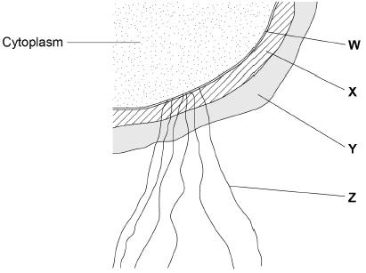

(a)     Name the structures labelled **W** to **Z** in the diagram.

**W** ________________________________________________________________

**X** _________________________________________________________________

**Y** _________________________________________________________________

**Z** _________________________________________________________________

**(2)**

(b)     Name the main biological molecule in:

**W** ________________________________________________________________

**X** _________________________________________________________________

**(2)**

(c)     Name the process by which prokaryotic cells divide.

___________________________________________________________________

**(1)**

(d)     Some prokaryotic cells can divide every 30 minutes. A liquid culture contained a starting population of 1.35 × 104 cells.

Assuming each cell divides every 30 minutes, calculate how many cells there will be after 3 hours. Assume no cells die during this time.

Answer = ____________________

**(2)**

**(Total 7 marks)**

**3.2.1.3 Methods of studying cells**

**Q1.**

(a)     Describe and explain how cell fractionation and ultracentrifugation can be used to isolate mitochondria from a suspension of animal cells.

___________________________________________________________________

___________________________________________________________________

___________________________________________________________________

___________________________________________________________________

___________________________________________________________________

___________________________________________________________________

___________________________________________________________________

___________________________________________________________________

___________________________________________________________________

___________________________________________________________________

**(5)**

(b)     Describe the principles and the limitations of using a transmission electron microscope to investigate cell structure.

___________________________________________________________________

___________________________________________________________________

___________________________________________________________________

___________________________________________________________________

___________________________________________________________________

___________________________________________________________________

___________________________________________________________________

___________________________________________________________________

___________________________________________________________________

___________________________________________________________________

**(5)**

**(Total 10 marks)**

**Q2.**

(a)     Contrast how an optical microscope and a transmission electron microscope work **and** contrast the limitations of their use when studying cells.

___________________________________________________________________

___________________________________________________________________

___________________________________________________________________

___________________________________________________________________

___________________________________________________________________

___________________________________________________________________

___________________________________________________________________

___________________________________________________________________

___________________________________________________________________

___________________________________________________________________

___________________________________________________________________

___________________________________________________________________

**(6)**

**(Total 6 marks)**

**Q3.**

The diagram shows a cholera bacterium. It has been magnified 50 000 times.

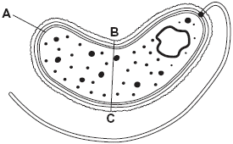

(a)     Name **A**.

___________________________________________________________________

**(1)**

(b)     Name **two** structures present in an epithelial cell from the small intestine that are **not** present in a cholera bacterium.

1. _________________________________________________________________

2. _________________________________________________________________

**(2)**

(c)     Cholera bacteria can be viewed using a transmission electron microscope (TEM) or a scanning electron microscope (SEM).

(i)      Give **one** advantage of using a TEM rather than a SEM.

______________________________________________________________

______________________________________________________________

**(1)**

(ii)     Give **one** advantage of using a SEM rather than a TEM.

______________________________________________________________

______________________________________________________________

______________________________________________________________

**(1)**

(d)     Calculate the actual width of the cholera bacterium between points **B** and **C**.  
Give your answer in micrometres and show your working.

____________________ µm

**(2)**

**(Total 7 marks)**

**Q4.**

A biologist prepared a sample of organelles labelled **C** from liver. He used the following method.

1.      Added to the liver tissues an ice-cold, buffered solution with the same water potential as the liver tissue.

2.      Mixed the liver and solution in a blender.

3.      Filtered the mixture from the blender.

4.      Spun the filtered liquid in a centrifuge at a low speed. A pellet appeared in the bottom of the centrifuge tube.

5.      Poured off the liquid above the pellet into a second centrifuge tube and spun this at a higher speed to obtain the sample of organelles labelled **C**.

(a)     Explain why the solution the biologist used was ice-cold, buffered and the same water potential as the liver tissue (step 1).

Ice-cold____________________________________________________________

___________________________________________________________________

Buffered____________________________________________________________

___________________________________________________________________

Same water potential__________________________________________________

___________________________________________________________________

**(3)**

(b)     Explain why the biologist used a blender and then filtered the mixture (steps 2 and 3).

___________________________________________________________________

___________________________________________________________________

___________________________________________________________________

___________________________________________________________________

___________________________________________________________________

**(2)**

(c)     Name the organelle that made up most of the first pellet after centrifuging at a low speed (step 4).

___________________________________________________________________

**(1)**

(d)     The second centrifuge tube was spun at a higher speed to obtain the sample of organelles labelled **C** in the diagram (step 5).

Suggest why.

___________________________________________________________________

___________________________________________________________________

___________________________________________________________________

**(1)**

**(Total 7 marks)**

**3.2.2 All cells arise from other cells**

**Q1.**

(a)     The photographs show two stages in mitosis of a plant cell.

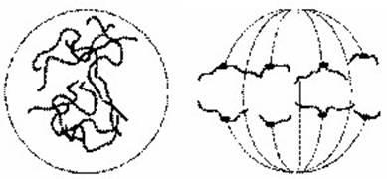

**A**                                                         **B**

Name stages **A** and **B**. In each case describe what is happening to the chromosomes.

(i)      Stage **A** _______________________________________________________

______________________________________________________________

______________________________________________________________

______________________________________________________________

**(2)**

(ii)     Stage **B** _______________________________________________________

______________________________________________________________

______________________________________________________________

______________________________________________________________

**(2)**

(b)     Describe **two** events during interphase which prepare a cell for mitosis.

1. _________________________________________________________________

___________________________________________________________________

2. _________________________________________________________________

___________________________________________________________________

**(2)**

**(Total 6 marks)**

**Q2.**

The diagrams show four stages of mitosis.

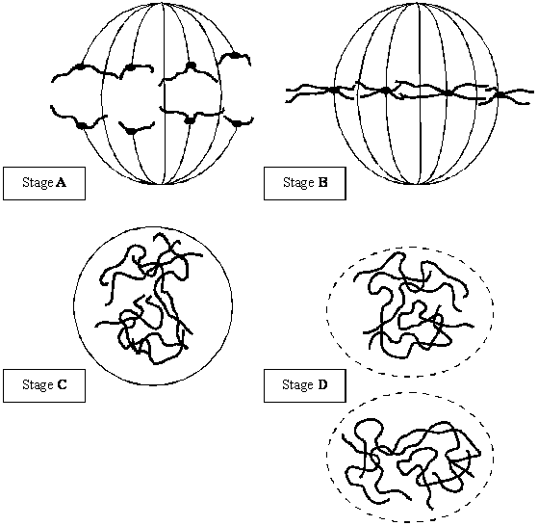

(a)     (i)      Name stage **A**.

______________________________________________________________

**(1)**

(ii)     Starting with stage **C**, give the stages **A** to **D** in the correct order.

**C** ______   ______   ______

**(1)**

(iii)     Describe and explain the appearance of one of the chromosomes in stage **B**.

______________________________________________________________

______________________________________________________________

______________________________________________________________

______________________________________________________________

**(2)**

(b)     Colchicine is a substance that prevents the formation of the spindle in mitosis. Dividing cells were treated with colchicine. This stopped them dividing. After a few hours, the colchicine was removed and the cells began to divide again. The diagram shows the chromosomes from one of the treated cells at stage **B** after the cell began dividing again.

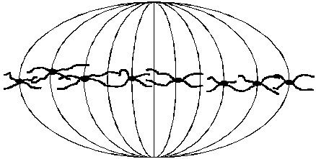

(i)      What has happened to the chromosome number?

______________________________________________________________

**(1)**

(ii)     Suggest an explanation for the change in the chromosome number.

______________________________________________________________

______________________________________________________________

**(1)**

**(Total 6 marks)**

**Q3.**

(a)     The following statements describe stages of mitosis.

**A** chromosomes align at the centre of the cell attached to spindle fibres  
**B** chromatids are in groups at the poles  
**C** chromosomes become visible  
**D** chromatids move towards the poles

Complete the table by entering the appropriate letter.

| **Stage of mitosis** | **Letter of description of the stage** |
| --- | --- |
| Prophase |  |
| Metaphase |  |
| Anaphase |  |
| Telophase |  |

**(3)**

(b)     The graph shows changes in the mass of DNA in a cell during one cell cycle.  
Five stages have been identified on the graph.

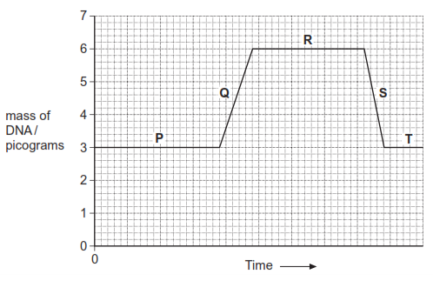

(i)      Which letter represents the stage when DNA is replicating?        

**(1)**

(ii)     Explain the change in the DNA content during stage **S**.

______________________________________________________________

______________________________________________________________

**(1)**

**(Total 5 marks)**

**Q4.**

A student prepared a stained squash of cells from the root tips of garlic to calculate a mitotic index. He:

**1.**   cut the end 5 mm from 10 garlic roots

**2.**   placed the root tips into a Petri dish containing 5 cm3 of hydrochloric acid for 12 minutes

**3.**   rinsed the root tips in distilled water

**4.**   placed one of the root tips on a microscope slide and added toluidine blue stain

**5.**   placed a coverslip onto the microscope slide, and gently pressed the coverslip downwards on the root tip

**6.**   observed the root tip using an optical microscope.

(a)  Suggest why the student soaked the root tips in hydrochloric acid in step **2**.

___________________________________________________________________

___________________________________________________________________

___________________________________________________________________

___________________________________________________________________

___________________________________________________________________

___________________________________________________________________

___________________________________________________________________

___________________________________________________________________

**(2)**

(b)  Pressing the coverslip downwards enabled the student to observe the stages of mitosis clearly.

Explain why.

___________________________________________________________________

___________________________________________________________________

___________________________________________________________________

___________________________________________________________________

___________________________________________________________________

___________________________________________________________________

___________________________________________________________________

**(2)**

The diagram below shows the student’s drawing of one field of view.

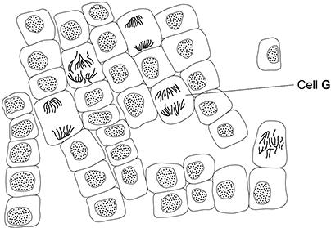

(c)  Name the stage of mitosis shown in cell **G**. Explain the appearance of this cell.

Stage of mitosis  _____________________________________________________

Explanation  ________________________________________________________

___________________________________________________________________

___________________________________________________________________

___________________________________________________________________

___________________________________________________________________

**(2)**

(d)  Use the diagram above to calculate a mitotic index for the cells in this field of view.

Mitotic index ____________________

**(1)**

(e)  Other students in the class followed the same method, but calculated different mitotic indices.

Apart from student errors, suggest **two** explanations why.

1  _________________________________________________________________

___________________________________________________________________

___________________________________________________________________

2  _________________________________________________________________

___________________________________________________________________

___________________________________________________________________

**(2)**

**(Total 9 marks)**

**Q5.**

(a)  What is a tumour?

___________________________________________________________________

___________________________________________________________________

___________________________________________________________________

___________________________________________________________________

**(2)**

(b)  Describe how you would determine a **reliable** mitotic index (MI) from tissue observed with an optical microscope.

Do **not** include details of how you would prepare the tissue observed with an optical microscope.

___________________________________________________________________

___________________________________________________________________

___________________________________________________________________

___________________________________________________________________

___________________________________________________________________

___________________________________________________________________

___________________________________________________________________

___________________________________________________________________

___________________________________________________________________

**(3)**

**(Total 5 marks)**

**Q6.**

(a)     The diagram shows a chromosome at the start of mitosis.



Describe and explain the appearance of the chromosome.

___________________________________________________________________

___________________________________________________________________

___________________________________________________________________

___________________________________________________________________

**(2)**

(b)     The photographs show two stages in mitosis.

Stage **A**                                                   Stage **B**

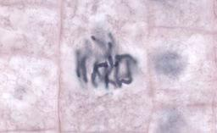 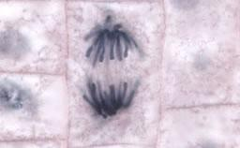

By Dr. phil.nat Thomas Geier, Fachgebiet Botanik der Forschungsanstalt Geisenheim.  
[CC-BY-SA-3.0], via Wikimedia Commons

Name stages **A** and **B**. Describe what is happening to the chromosomes in each stage.

(i)      Stage **A** ___________________________

______________________________________________________________

______________________________________________________________

______________________________________________________________

**(2)**

(ii)     Stage **B** ___________________________

______________________________________________________________

______________________________________________________________

______________________________________________________________

**(2)**

**(Total 6 marks)**

**3.2.3 Transport across membranes**

**Q1.**

The diagram shows part of a cell surface membrane.

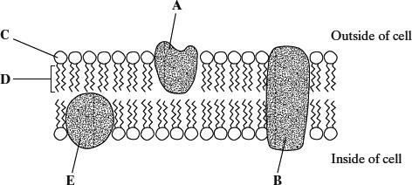

(a)     Complete the table by writing the letter from the diagram which refers to each part of the membrane.

| **Part of membrane** | **Letter** |
| --- | --- |
| Channel protein |  |
| Contains only the elements carbon and hydrogen |  |

**(2)**

(b)     Explain why the structure of a membrane is described as *fluid-mosaic*.

___________________________________________________________________

___________________________________________________________________

___________________________________________________________________

___________________________________________________________________

**(2)**

(c)     When pieces of carrot are placed in water, chloride ions are released from the cell vacuoles. Identical pieces of carrot were placed in water at different temperatures. The concentration of chloride ions in the water was measured after a set period of time. The graph shows the results.

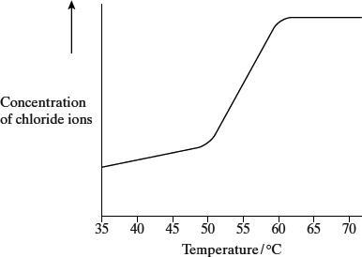

Describe and explain the shape of the curve.

___________________________________________________________________

___________________________________________________________________

___________________________________________________________________

___________________________________________________________________

___________________________________________________________________

___________________________________________________________________

**(3)**

**(Total 7 marks)**

**Q2.**

The diagram shows part of a plasma membrane.

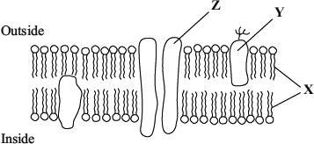

(a)     Describe **two** functions of the structure made from the parts labelled **X**.

1. _________________________________________________________________

___________________________________________________________________

2. _________________________________________________________________

___________________________________________________________________

**(2)**

(b)     Give **one** function of the molecule labelled **Y**.

___________________________________________________________________

___________________________________________________________________

**(1)**

(c)     The part labelled **Z** is involved in facilitated diffusion of substances across the membrane.

(i)      Give **one** similarity in the way in which active transport and facilitated diffusion transport substances across the membrane.

______________________________________________________________

______________________________________________________________

(ii)     Give **one** way in which active transport differs from facilitated diffusion.

______________________________________________________________

______________________________________________________________

**(2)**

(iii)     The graph shows the relationship between the concentration of a substance outside a cell and the rate of entry of this substance into the cell.

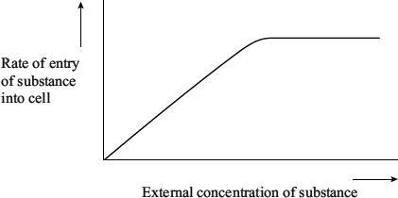

Explain the evidence from the graph that this substance is entering the cell by facilitated diffusion and not by simple diffusion.

______________________________________________________________

______________________________________________________________

______________________________________________________________

______________________________________________________________

**(2)**

**(Total 7 marks)**

**Q3.**

Six cylinders of a standard size were cut from a single large potato. One cylinder was placed in distilled water and the others were placed in sucrose solutions of different concentrations. The length of each cylinder was measured every 5 minutes for the next 50 minutes.

The graph shows the changes in length at each sucrose concentration.

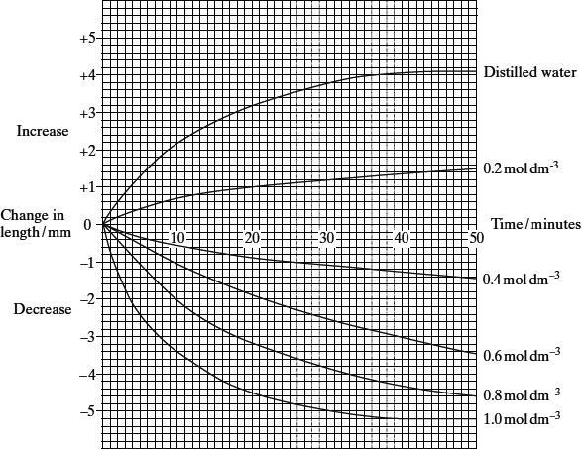

(a)     Explain why

(i)      the potato cylinder in distilled water increased in length;

______________________________________________________________

______________________________________________________________

______________________________________________________________

______________________________________________________________

**(2)**

(ii)     the potato cylinder in the 1.0 mol dm–3 sucrose solution showed no further   
decrease in length after 40 minutes.

______________________________________________________________

______________________________________________________________

______________________________________________________________

______________________________________________________________

**(2)**

(b)     (i)      Describe the difference in the rate of decrease in length during the first 10 minutes between the cylinder in the 0.4 mol dm–3 and the cylinder in  
the 0.8 mol dm–3 solution.

______________________________________________________________

______________________________________________________________

**(1)**

(ii)     Use your knowledge of water potential to explain this difference.

______________________________________________________________

______________________________________________________________

**(1)**

(c)     After 45 minutes the potato cylinder in the 0.8 mol dm–3 solution was removed and blue dye added to this solution. Some of this blue-stained solution was drawn into a syringe. A drop was then released, slowly, halfway down a test tube of fresh 0.8 mol dm–3 sucrose solution as shown in the diagram. The blue drop quickly moved to the surface of the liquid in the test tube.

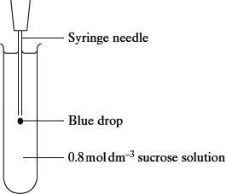

(i)      The density of a solution depends on its concentration. The more concentrated the solution the greater its density. Explain why the blue drop had a lower density and therefore moved up.

______________________________________________________________

______________________________________________________________

______________________________________________________________

______________________________________________________________

**(2)**

(ii)     A sucrose solution of concentration 0.3 mol dm–3 has a water potential which is equivalent to that of the potato cells. Describe and explain what would happen to the blue drop from this solution.

______________________________________________________________

______________________________________________________________

______________________________________________________________

______________________________________________________________

**(2)**

**(Total 10 marks)**

**Q4.**

(a)     The structure of a plasma membrane is described as a fluid mosaic.  
Explain why.

___________________________________________________________________

___________________________________________________________________

___________________________________________________________________

___________________________________________________________________

**(2)**

(b)     Give **two** functions of proteins in plasma membranes.

1. _________________________________________________________________

2. _________________________________________________________________

**(2)**

Scientists investigated the movement of calcium ions across the plasma membrane of human cells. They placed human cells in a solution of calcium ions. At regular intervals, they measured the concentration of calcium ions in the external solution and the concentration of calcium ions inside the cells. Their results are shown in the graph.

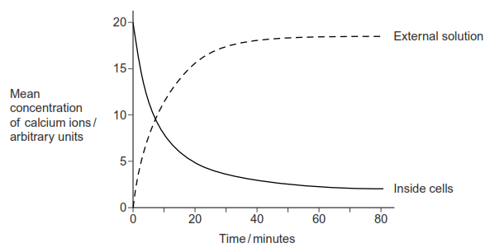

(c)     By what process did the calcium ions leave the cells after 10 minutes? Use evidence from the graph to support your answer.

___________________________________________________________________

___________________________________________________________________

___________________________________________________________________

___________________________________________________________________

**(2)**

**(Total 6 marks)**

**Q5.**

(a)     Describe **two** differences between active transport and facilitated diffusion.

1. _________________________________________________________________

___________________________________________________________________

2. _________________________________________________________________

___________________________________________________________________

**(2)**

(b)     Explain why molecules of oxygen and carbon dioxide are able to diffuse across membranes.

___________________________________________________________________

___________________________________________________________________

___________________________________________________________________

___________________________________________________________________

___________________________________________________________________

**(2)**

(c)     Explain why ventilation of the lungs increases the efficiency of gas exchange.

___________________________________________________________________

___________________________________________________________________

___________________________________________________________________

___________________________________________________________________

___________________________________________________________________

**(2)**

**(Total 6 marks)**

**Q6.**

(a)     Oxygen and water move through plasma membranes into cells. Describe **two** ways in which these movements are similar.

1. _________________________________________________________________

___________________________________________________________________

2. _________________________________________________________________

___________________________________________________________________

**(2)**

The graph shows the effect of concentration on the rate of uptake of magnesium ions by root hair cells.

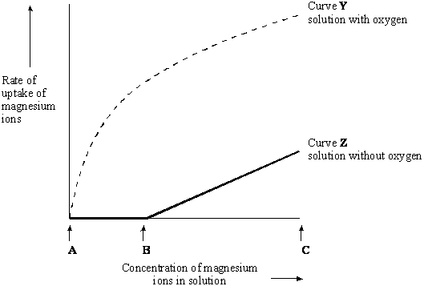

(b)     For curve **Y** name the process the cells are using to absorb magnesium ions between concentrations **A** and **B**. Use information in the graph to explain your answer.

Name of process _____________________________________________________

Explanation _________________________________________________________

___________________________________________________________________

___________________________________________________________________

**(2)**

(c)     In the solution without oxygen, explain why no magnesium ions are taken up between concentrations **A** and **B**.

___________________________________________________________________

___________________________________________________________________

**(1)**

(d)     For curve **Z** explain why the rate of uptake increases between **B** and **C**.

___________________________________________________________________

___________________________________________________________________

**(1)**

**(Total 6 marks)**

**3.2.4 Cell recognition and the immune system**

**Q1.**

(a)     An antigen in a vaccine leads to the production of antibodies. Describe the part played by B lymphocytes in this process.

___________________________________________________________________

___________________________________________________________________

___________________________________________________________________

___________________________________________________________________

___________________________________________________________________

___________________________________________________________________

___________________________________________________________________

**(4)**

(b)     Hepatitis B vaccine contains a viral antigen produced by genetically modified bacteria. Describe how the isolated gene that codes for a protein in the virus’s coat could be transferred to the bacterial cells.

___________________________________________________________________

___________________________________________________________________

___________________________________________________________________

___________________________________________________________________

___________________________________________________________________

___________________________________________________________________

___________________________________________________________________

**(3)**

**(Total 7 marks)**

**Q2.**

(a)     What is an antigen?

___________________________________________________________________

___________________________________________________________________

___________________________________________________________________

___________________________________________________________________

**(2)**

(b)     A zookeeper was bitten by a snake. The bite contained venom which is a poison.  
He was given an injection of antivenom. This antivenom contained antibodies against this snake venom.

The antivenom did not give the zookeeper lasting protection against this snake venom. Explain why.

___________________________________________________________________

___________________________________________________________________

___________________________________________________________________

___________________________________________________________________

*(Extra space)* ________________________________________________________

___________________________________________________________________

**(2)**

**(Total 4 marks)**

**Q3.**

Doctors use Zevalin to kill cancerous B-cells. Zevalin is a monoclonal antibody which has a highly radioactive substance called yttrium attached to it. The antibody binds to the surface of B-cells and the radioactivity kills the cells.

(a)     Only B-cells are killed by Zevalin.

Explain why.

___________________________________________________________________

___________________________________________________________________

___________________________________________________________________

___________________________________________________________________

**(2)**

The cancerous B-cells are found mainly in the lymphatic system of patients. Before treating any patient with Zevalin containing yttrium, doctors test the patient with a different form of Zevalin. This form has radioactive indium attached to the antibody instead of yttrium. The radioactivity from indium is strong enough for doctors to detect but not strong enough to kill a patient’s cells.

The diagram shows the lymphatic systems of two patients, **P** and **Q**, after being given Zevalin with indium.  The crosses (**+**) show where indium was detected.

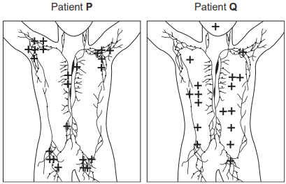

(b)     The doctors decided they could treat Patient **P** with Zevalin containing yttrium but **not** Patient **Q**.  
Suggest why Patient **P** could be treated with Zevalin containing yttrium and Patient **Q** could not.

___________________________________________________________________

___________________________________________________________________

___________________________________________________________________

___________________________________________________________________

___________________________________________________________________

___________________________________________________________________

*(Extra space)* ________________________________________________________

___________________________________________________________________

___________________________________________________________________

**(3)**

(c)     Suggest **one** reason for the difference in distribution of the radioactivity detected in these patients.

___________________________________________________________________

___________________________________________________________________

___________________________________________________________________

___________________________________________________________________

**(2)**

(d)     The antibody in Zevalin comes from mice. Patients are tested for antibodies against Zevalin before treatment for their cancer.  
Suggest why.

___________________________________________________________________

___________________________________________________________________

___________________________________________________________________

___________________________________________________________________

**(2)**

**(Total 9 marks)**

**Q4.**

(a)     The MMR vaccine contains *attenuated* microorganisms.  
What is an *attenuated* microorganism?

___________________________________________________________________

___________________________________________________________________

___________________________________________________________________

___________________________________________________________________

**(2)**

(b)     A child was given the MMR vaccine and was given a second dose of the vaccine as a booster later.

(i)      It took more than a week for antibodies to appear in the child’s blood after the first vaccination. Explain why.

______________________________________________________________

______________________________________________________________

______________________________________________________________

______________________________________________________________

**(2)**

(ii)     The concentration of antibodies increased immediately after the second vaccination.  
Explain why.

______________________________________________________________

______________________________________________________________

______________________________________________________________

______________________________________________________________

**(2)**

**(Total 6 marks)**

**Q5.**

Read the following passage.

An anti-gal antibody is a type of antibody that helps to fight infections caused  
by bacteria. If a person has a bacterial infection, for example *Salmonella*, anti-gal  
antibodies bind to antigens on the surface of the *Salmonella*. Not all the  
anti-gal antibodies are used to fight the infection. Even after the infection, anti-gal  
antibodies remain in the blood.                                                                                                    5

Scientists have made adaptor molecules to try to use the anti-gal antibodies  
against viruses such as HIV. The adaptor molecules are proteins. Each adaptor  
molecule had a receptor site to which the HIV binds. This receptor site was  
similar to the receptor site on human cells to which the HIV binds. The  
adaptor molecule has another site to which an anti-gal antibody will bind.                               10

The scientists then investigated whether adding adaptor molecules and anti-gal  
antibodies can prevent HIV entering cells. They added adaptor molecules  
and anti-gal antibodies to a culture of human cells. They then added HIV  
to the culture. Their results showed that 90% of the virus particles failed  
to infect cells.                                                                                                                             15

The scientists are hoping to develop a different type of adaptor molecule to use against MRSA.

(a)     (i)      What is an antigen? (line 3)

______________________________________________________________

______________________________________________________________

______________________________________________________________

______________________________________________________________

**(2)**

(ii)     Explain why antibodies against *Salmonella* do not normally bind to HIV.

______________________________________________________________

______________________________________________________________

______________________________________________________________

______________________________________________________________

**(2)**

(iii)     Explain how the adaptor molecule allows anti-gal antibodies to associate with HIV.

______________________________________________________________

______________________________________________________________

______________________________________________________________

______________________________________________________________

**(2)**

(b)     Describe how humans produce antibodies against a pathogen such as *Salmonella*.

___________________________________________________________________

___________________________________________________________________

___________________________________________________________________

___________________________________________________________________

___________________________________________________________________

___________________________________________________________________

___________________________________________________________________

___________________________________________________________________

___________________________________________________________________

___________________________________________________________________

*(Extra space)* ________________________________________________________

___________________________________________________________________

___________________________________________________________________

___________________________________________________________________

___________________________________________________________________

___________________________________________________________________

**(6)**

(c)     (i)      HIV infects some human cells, such as T-cells, but not others. Suggest why.

______________________________________________________________

______________________________________________________________

______________________________________________________________

______________________________________________________________

**(2)**

(ii)     Antibiotics are **not** used to treat viral infections, such as HIV. Explain why.

______________________________________________________________

______________________________________________________________

______________________________________________________________

______________________________________________________________

**(2)**

(d)     (i)      When HIV, anti-gal and the *adaptor molecule* were added to a culture of human cells, 90% of the virus did **not** infect human cells. (lines 12-15). Explain why.

______________________________________________________________

______________________________________________________________

______________________________________________________________

______________________________________________________________

**(2)**

(ii)     Explain why a different type of adaptor molecule will have to be made to use against MRSA. (lines 16-17)

______________________________________________________________

______________________________________________________________

______________________________________________________________

______________________________________________________________

**(2)**

**(Total 20 marks)**

**Q6.**

(a)     The graph shows the number of deaths from influenza per year in a developed country.

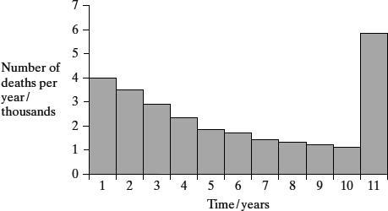

(i)      Suggest an explanation for the change in the number of deaths from influenza during the first 10 years.

______________________________________________________________

______________________________________________________________

**(1)**

(ii)     Suggest an explanation for the large increase in the number of deaths from influenza in year 11.

______________________________________________________________

______________________________________________________________

______________________________________________________________

______________________________________________________________

**(2)**

(b)     The diagram shows some of the structures on the outside of an influenza virus.

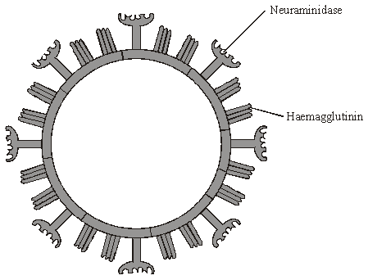

Haemagglutinin and neuraminidase are protein molecules. Haemagglutinin binds to receptor molecules on the surface of epithelial cells in the breathing system.  
Neuraminidase is an enzyme which breaks down molecules in the surface membrane of epithelial cells and allows the viruses to be released from the cells.

(i)      Describe how T lymphocytes recognise and respond to the influenza virus.

______________________________________________________________

______________________________________________________________

______________________________________________________________

______________________________________________________________

**(2)**

(ii)     Describe how B lymphocytes respond to the influenza virus.

______________________________________________________________

______________________________________________________________

______________________________________________________________

______________________________________________________________

**(2)**

(c)     New drugs have recently become available for treating influenza. One type is a neuraminidase inhibitor. Explain how this type of drug would act as a treatment for influenza.

___________________________________________________________________

___________________________________________________________________

___________________________________________________________________

___________________________________________________________________

**(2)**

**(Total 9 marks)**

**3.3.1 Surface area to volume ratio**

**Q1.**

**Figure 1** shows images of gills from two fish as seen through an optical microscope.

Image **C** shows gills from a fish with healthy gills.

Image **D** shows gills from a fish with damaged gills.

**Figure 1**

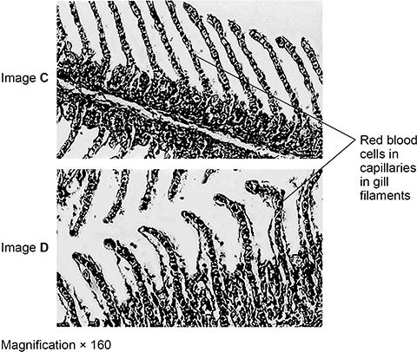

(a)  To observe the fish gills with the optical microscope, the scientists used **two** different stains. The first stain binds to DNA; the second stain binds to the red blood cells.

Explain why a second stain would be needed to stain the red blood cells. Suggest which molecule the stain could bind to in the red blood cells.

Explanation  ________________________________________________________

___________________________________________________________________

___________________________________________________________________

Molecule  __________________________________________________________

**(2)**

(b)  Using **Figure 1**, the scientists calculated the surface area to volume ratios for each gill filament in these two fish. Some of their results are shown in **Table 1**.

Complete **Table 1**. State your calculated volume and surface area:volume ratio to 2 significant figures.

| **Table 1** | | | |
| --- | --- | --- | --- |
| **Fish gill** | **Surface area / µm2** | **Volume / µm3** | **Surface area:volume ratio** |
| Healthy | 7.4 × 103 | 2.3 × 104 | __________ |
| Damaged | 1.1 × 104 | __________ | 0.13:1 |

**(2)**

(c)  The damage to the gills causes uncontrolled cell division in the cells around the capillaries in the gill filaments.

Other than surface area:volume ratio, describe **one** way this uncontrolled cell division changes the gills, as shown in **Figure 1**.

Explain how this difference would affect gas exchange.

Difference  _________________________________________________________

___________________________________________________________________

___________________________________________________________________

Explanation  ________________________________________________________

___________________________________________________________________

___________________________________________________________________

___________________________________________________________________

___________________________________________________________________

___________________________________________________________________

**(3)**

**Figure 2** shows the general pattern of blood circulation in fish.

**Figure 2**

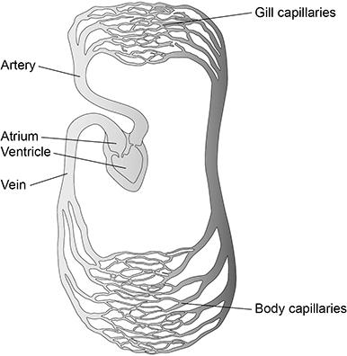

(d)  Use **Figure 2** to complete **Table 2** to show **two** differences between the circulation of blood in fish and the circulation of blood in a mammal.

| **Table 2** | | |
| --- | --- | --- |
| **Difference** | **Circulation of blood in fish** | **Circulation of blood in mammal** |
| **1** |  |  |
| **2** |  |  |

**(2)**

**(Total 9 marks)**

**Q2.**

*Uronema marinum* is a single-celled eukaryotic organism. The diagram below is a photograph of *U. marinum* taken through an optical microscope.

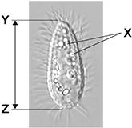

(a)  In large cells of *U. marinum*, most mitochondria are found close to the cell-surface membrane. In smaller cells, the mitochondria are distributed evenly throughout the cytoplasm. Mitochondria use oxygen during aerobic respiration.

Use this information and your knowledge of surface area to volume ratios to suggest an explanation for the position of mitochondria in **large** *U. marinum* cells.

___________________________________________________________________

___________________________________________________________________

___________________________________________________________________

___________________________________________________________________

___________________________________________________________________

___________________________________________________________________

**(2)**

**(Total 2 marks)**

**3.3.2 Gas Exchange**

**Q1.**

(a)     Describe how air is taken into the lungs.

___________________________________________________________________

___________________________________________________________________

___________________________________________________________________

___________________________________________________________________

___________________________________________________________________

___________________________________________________________________

**(3)**

The volume of air breathed in and out of the lungs during each breath is called the tidal volume. The breathing rate and tidal volume were measured for a cyclist pedalling at different speeds. The graph shows the results.

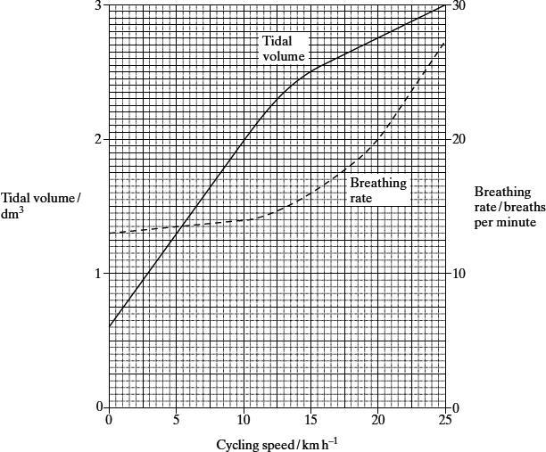

(b)     Describe the **two** curves.

(i)      Tidal volume

______________________________________________________________

______________________________________________________________

______________________________________________________________

(ii)     Breathing rate

______________________________________________________________

______________________________________________________________

______________________________________________________________

**(2)**

(c)     Calculate the total volume of air breathed in and out per minute when the cyclist is cycling at 20 km h–1. Show your working.

____________________ dm3

**(2)**

**(Total 7 marks)**

**Q2.**

(a)     When first hatched, the young of some species of fish are less than 2 mm long.  
Explain how these young fish get enough oxygen to their cells without having gills.

___________________________________________________________________

___________________________________________________________________

___________________________________________________________________

___________________________________________________________________

**(2)**

(b)     Mackerel are fast swimming fish whereas toadfish only swim slowly. The table shows some features of the gills of these fish.

|  | **Thickness of lamellae / µm** | **Number of lamellae per mm of gill length** |
| --- | --- | --- |
| Mackerel | 5 | 32 |
| Toadfish | 35 | 8 |

Use evidence from the table to explain how mackerel are able to swim faster than toadfish.

___________________________________________________________________

___________________________________________________________________

___________________________________________________________________

___________________________________________________________________

___________________________________________________________________

**(3)**

**(Total 5 marks)**

**Q3.**

**Figure 1** shows images of gills from two fish as seen through an optical microscope.

Image **C** shows gills from a fish with healthy gills.

Image **D** shows gills from a fish with damaged gills.

**Figure 1**



(a)  To observe the fish gills with the optical microscope, the scientists used **two** different stains. The first stain binds to DNA; the second stain binds to the red blood cells.

Explain why a second stain would be needed to stain the red blood cells. Suggest which molecule the stain could bind to in the red blood cells.

Explanation  ________________________________________________________

___________________________________________________________________

___________________________________________________________________

Molecule  __________________________________________________________

**(2)**

(b)  Using **Figure 1**, the scientists calculated the surface area to volume ratios for each gill filament in these two fish. Some of their results are shown in **Table 1**.

Complete **Table 1**. State your calculated volume and surface area:volume ratio to 2 significant figures.

| **Table 1** | | | |
| --- | --- | --- | --- |
| **Fish gill** | **Surface area / µm2** | **Volume / µm3** | **Surface area:volume ratio** |
| Healthy | 7.4 × 103 | 2.3 × 104 | __________ |
| Damaged | 1.1 × 104 | __________ | 0.13:1 |

**(2)**

(c)  The damage to the gills causes uncontrolled cell division in the cells around the capillaries in the gill filaments.

Other than surface area:volume ratio, describe **one** way this uncontrolled cell division changes the gills, as shown in **Figure 1**.

Explain how this difference would affect gas exchange.

Difference  _________________________________________________________

___________________________________________________________________

___________________________________________________________________

Explanation  ________________________________________________________

___________________________________________________________________

___________________________________________________________________

___________________________________________________________________

___________________________________________________________________

___________________________________________________________________

**(3)**

**Figure 2** shows the general pattern of blood circulation in fish.

**Figure 2**



(d)  Use **Figure 2** to complete **Table 2** to show **two** differences between the circulation of blood in fish and the circulation of blood in a mammal.

| **Table 2** | | |
| --- | --- | --- |
| **Difference** | **Circulation of blood in fish** | **Circulation of blood in mammal** |
| **1** |  |  |
| **2** |  |  |

**(2)**

**(Total 9 marks)**

**Q4.**

(a)     Describe **two** differences between active transport and facilitated diffusion.

1. _________________________________________________________________

___________________________________________________________________

2. _________________________________________________________________

___________________________________________________________________

**(2)**

(b)     Explain why molecules of oxygen and carbon dioxide are able to diffuse across membranes.

___________________________________________________________________

___________________________________________________________________

___________________________________________________________________

___________________________________________________________________

___________________________________________________________________

**(2)**

(c)     Explain why ventilation of the lungs increases the efficiency of gas exchange.

___________________________________________________________________

___________________________________________________________________

___________________________________________________________________

___________________________________________________________________

___________________________________________________________________

**(2)**

**(Total 6 marks)**

**Q5.**

(a)  Describe how the structure of the insect gas exchange system:

•   provides cells with sufficient oxygen

•   limits water loss.

Explain your answers.

___________________________________________________________________

___________________________________________________________________

___________________________________________________________________

___________________________________________________________________

___________________________________________________________________

___________________________________________________________________

___________________________________________________________________

___________________________________________________________________

___________________________________________________________________

___________________________________________________________________

___________________________________________________________________

___________________________________________________________________

**(5)**

(b)  Describe how humans breathe in and out.

___________________________________________________________________

___________________________________________________________________

___________________________________________________________________

___________________________________________________________________

___________________________________________________________________

___________________________________________________________________

___________________________________________________________________

___________________________________________________________________

___________________________________________________________________

___________________________________________________________________

___________________________________________________________________

___________________________________________________________________

**(5)**

**(Total 10 marks)**

**Q6.**

This question should be written in continuous prose, where appropriate.  
Quality of Written Communication will be assessed in the answer.

(a)     Explain how the ventilation mechanism of a fish and the structure of its gills result in the efficient uptake of oxygen from water.

___________________________________________________________________

___________________________________________________________________

___________________________________________________________________

___________________________________________________________________

___________________________________________________________________

___________________________________________________________________

___________________________________________________________________

___________________________________________________________________

___________________________________________________________________

___________________________________________________________________

___________________________________________________________________

___________________________________________________________________

___________________________________________________________________

___________________________________________________________________

___________________________________________________________________

**(6)**

**Table 1** compares some features of water and air.

| **Feature** | **Water** | **Air** |
| --- | --- | --- |
| Relative density | 1000 | 1 |
| Maximum concentration of oxygen / cm3 dm–3 | 9 | 130 |

**Table 1**

**Table 2** shows some features of gas exchange in a fish and in a mammal.

| **Feature** | **Fish** | **Mammal** |
| --- | --- | --- |
| Percentage of oxygen extracted from water or air | 80 | 25 |
| Oxygen consumption at rest / cm3 kg–1 hour–1 | 100 | 200 |

**Table 2**

(b)     (i)      The fish has a body mass of 0.2 kg. Calculate the volume of water it will need to pass over its gills each hour to supply the oxygen required when resting. Show your working.

Answer ____________________ dm3 / hour–1

**(2)**

(ii)     Ventilation in mammals involves movement of air to and from the gas exchange surface in a tidal pattern. Using information in the tables, explain why it is easier to move water over the gas exchange surface of a fish in one direction rather than in a tidal pattern.

______________________________________________________________

______________________________________________________________

______________________________________________________________

______________________________________________________________

**(2)**

(c)     A rise in the temperature of water decreases the amount of oxygen dissolved in the water. As the water temperature rises, the rate of ventilation in a fish also rises. Explain the advantage of this.

___________________________________________________________________

___________________________________________________________________

**(2)**

**(Total 12 marks)**

**3.3.4.1 Mass transport in animals**

**Q1.**

The graph shows the changes in pressure which take place in the aorta of a mouse during several heartbeats.

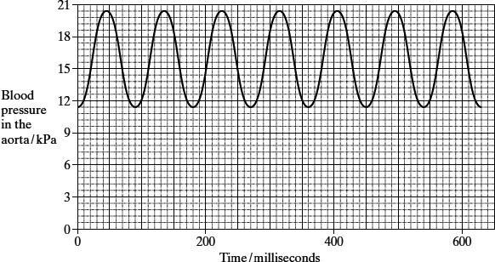

(a)     Which chamber of the heart produces the increase in pressure recorded in the aorta?

___________________________________________________________________

**(1)**

(b)     The pressure of blood in the aorta decreases during each heartbeat but does not fall below 10 kPa. Explain what causes the pressure of blood to

(i)      decrease during each heartbeat;

______________________________________________________________

______________________________________________________________

**(1)**

(ii)     stay above 10 kPa.

______________________________________________________________

______________________________________________________________

______________________________________________________________

______________________________________________________________

**(2)**

(c)The heart rate of a mouse is much higher than the heart rate of a human. Use the graph to calculate the heart rate of the mouse. Show your working.

Heart rate = ____________________ beats per minute

**(2)**

(d)     The cardiac output is the volume of blood pumped by a heart in one minute. The stroke volume is the volume of blood pumped by a heart in a single heartbeat.

cardiac output = stroke volume × heart rate

The cardiac output for a mouse with a heart rate of 550 beats per minute is 16.6 cm3 per minute. Calculate the stroke volume for this mouse. Show your working.

Stroke volume = ____________________ cm3

**(2)**

**(Total 8 marks)**

**Q2.**

(a)     A woman takes moderate exercise. Explain what causes her heart rate to increase while she exercises.

___________________________________________________________________

___________________________________________________________________

___________________________________________________________________

___________________________________________________________________

___________________________________________________________________

___________________________________________________________________

___________________________________________________________________

___________________________________________________________________

___________________________________________________________________

___________________________________________________________________

___________________________________________________________________

___________________________________________________________________

**(6)**

(b)     An electrocardiogram (ECG) measures the electrical changes occurring in cardiac muscle as a heart is beating. An ECG trace for a healthy person and an ECG trace for a person suffering from heart disease are shown.

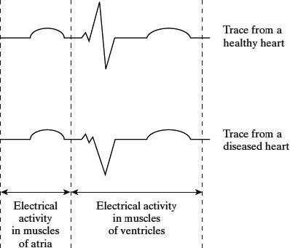

(i)      Describe the route taken when electrical impulses are transmitted from the sinoatrial node to the muscles of the ventricles in a healthy heart.

______________________________________________________________

______________________________________________________________

______________________________________________________________

______________________________________________________________

**(2)**

(ii)     Explain how information from these ECG traces suggests that the damage caused to the diseased heart is unlikely to have affected the sinoatrial node.

______________________________________________________________

______________________________________________________________

______________________________________________________________

______________________________________________________________

**(2)**

**(Total 10 marks)**

**Q3.**

Tissue fluid is formed when water and small molecules pass out of capillaries at their arterial end. The diagram shows some pressures involved in tissue fluid formation. The relative lengths of the arrows indicate the size of the pressures.

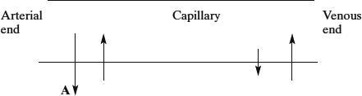

(a)     What causes the pressure represented by the arrow labelled **A**?

___________________________________________________________________

___________________________________________________________________

**(1)**

(b)     Explain why there is a net loss of water from a capillary at the arterial end.

___________________________________________________________________

___________________________________________________________________

___________________________________________________________________

___________________________________________________________________

**(2)**

(c)     The total volume of fluid that passes from the capillaries to the surrounding tissue fluid is normally greater than the volume that is reabsorbed into them. Describe what happens to this extra fluid.

___________________________________________________________________

___________________________________________________________________

___________________________________________________________________

___________________________________________________________________

**(2)**

(d)     Tissue fluid accumulates in the tissues of people who do not eat enough protein. Explain why.

___________________________________________________________________

___________________________________________________________________

___________________________________________________________________

___________________________________________________________________

**(2)**

**(Total 7 marks)**

**Q4.**

The graph shows changes in pressure in the aorta, left ventricle and left atrium during one heart beat.

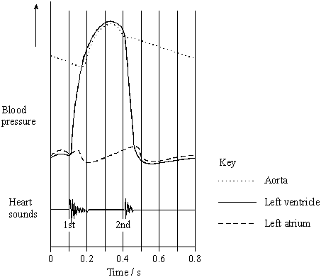

(a)     The maximum pressure in the left atrium is lower than the maximum pressure in the left ventricle. What causes this difference in maximum pressure?

___________________________________________________________________

___________________________________________________________________

**(1)**

(b)     A stethoscope can be used to listen to the sounds made by the heart.

(i)      What is the evidence from the graph that the first heart sound is caused by the atrioventricular valve closing?

______________________________________________________________

______________________________________________________________

**(1)**

(ii)     What causes the second heart sound? Give the reason for your answer.

______________________________________________________________

______________________________________________________________

______________________________________________________________

______________________________________________________________

**(2)**

**(Total 4 marks)**

**Q5.**

The diagram shows some blood vessels in muscle tissue.

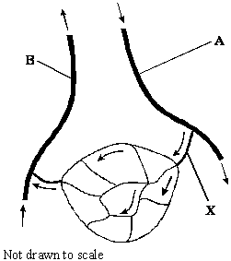

(a)     (i)      Which type of blood vessel is **X**?

______________________________________________________________

**(1)**

(ii)     Name **two** substances which are at a higher concentration in the blood at **A** than in the blood at **B**.

1. ____________________________________________________________

2. ____________________________________________________________

**(1)**

(b)     The table shows the mean diameter of the lumen and the rate of blood flow in some types of human blood vessel.

| **Type of blood vessel** | **Mean diameter of lumen / μm** | **Rate of blood flow / cm s–1** |
| --- | --- | --- |
| Artery | 400 | 10 – 40 |
| Arteriole | 30 | 0.1 – 10 |
| Capillary | 8 | less than 0.1 |

Using information in the table, explain what causes the rate of blood flow to be slower in capillaries than in other vessels.

___________________________________________________________________

___________________________________________________________________

___________________________________________________________________

___________________________________________________________________

**(2)**

(c)     (i)      Which type of blood vessel has most elastic tissue in its wall?

______________________________________________________________

**(1)**

(ii)     How does this elastic tissue help to smooth out the flow of blood in the blood vessel?

______________________________________________________________

______________________________________________________________

______________________________________________________________

______________________________________________________________

**(2)**

**(Total 7 marks)**

**Q6.**

The diagram shows the pathways in the heart for the conduction of electrical impulses during the cardiac cycle.

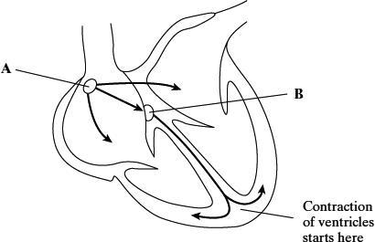

(a)     The table shows the blood pressure in the left atrium, the left ventricle and the aorta at different times during part of a cardiac cycle.

|  | **Blood pressure / kPa** | | |
| --- | --- | --- | --- |
| **Time / s** | **Left atrium** | **Left ventricle** | **Aorta** |
| 0.0 | 0.5 | 0.4 | 10.6 |
| 0.1 | 1.2 | 0.7 | 10.6 |
| 0.2 | 0.3 | 6.7 | 10.6 |
| 0.3 | 0.4 | 17.3 | 16.0 |
| 0.4 | 0.8 | 8.0 | 12.0 |

(i)      At which time is blood flowing into the aorta?

______________________________________________________________

**(1)**

(ii)     Between which times are the atrioventricular valves closed?

______________________________________________________________

**(1)**

(b)     The maximum pressure in the left ventricle is higher than the maximum pressure in the right ventricle. What causes this difference in pressure?

___________________________________________________________________

___________________________________________________________________

**(1)**

(c)     The information below compares some features of different blood vessels.

|  | | **Blood vessel** | | |
| --- | --- | --- | --- | --- |
|  | | **Artery** | **Capillary** | **Vain** |
| **Property** | Mean diameter of vessel | 4.0 mm | 8.0 μm | 5.0 mm |
| Mean thickness of wall | 1.0 mm | 0.5 μm | 0.5 mm |
|  | | **Relative thickness (shown by length of bar)** | | |
| **Tissues present in wall** | Endothelium |  |  |  |
| Elastic tissue |
| Muscle |

Use the information to explain how the structures of the walls of arteries, veins and capillaries are related to their functions.

___________________________________________________________________

___________________________________________________________________

___________________________________________________________________

___________________________________________________________________

___________________________________________________________________

___________________________________________________________________

___________________________________________________________________

___________________________________________________________________

___________________________________________________________________

___________________________________________________________________

___________________________________________________________________

___________________________________________________________________

**(6)**

**(Total 9 marks)**

**3.3.4.2 Mass transport in plants**

**Q1.**

(a)     The graphs show the daily changes in environmental temperature and light intensity, and changes in the diameter of the trunk of a pine tree.

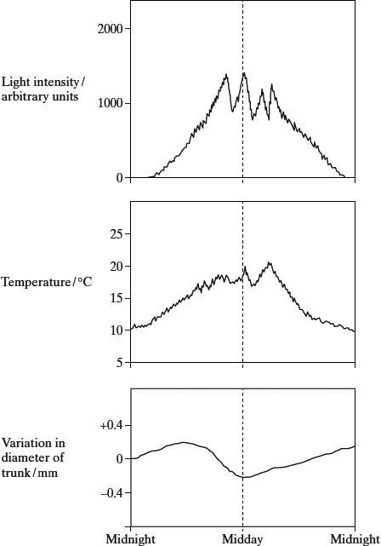

Use information from the graphs, and your knowledge of the cohesion-tension theory of water movement through a plant, to explain why the diameter of the trunk is smallest at midday.

___________________________________________________________________

___________________________________________________________________

___________________________________________________________________

___________________________________________________________________

___________________________________________________________________

___________________________________________________________________

___________________________________________________________________

___________________________________________________________________

___________________________________________________________________

___________________________________________________________________

___________________________________________________________________

___________________________________________________________________

___________________________________________________________________

___________________________________________________________________

**(6)**

(b)     Describe and explain **three** ways in which the leaves of xerophytic plants may be adapted to reduce water loss.

___________________________________________________________________

___________________________________________________________________

___________________________________________________________________

___________________________________________________________________

___________________________________________________________________

___________________________________________________________________

**(3)**

**(Total 9 marks)**

**Q2.**

(a)     Describe how water is moved through a plant according to the *cohesion-tension* hypothesis.

___________________________________________________________________

___________________________________________________________________

___________________________________________________________________

___________________________________________________________________

___________________________________________________________________

___________________________________________________________________

___________________________________________________________________

___________________________________________________________________

**(4)**

(b)     The mass of water lost from a plant was investigated. The same plant was used in every treatment and the plant was subjected to identical environmental conditions. In some treatments, the leaves were coated with a type of grease. This grease provides a waterproof barrier. The results of the investigation are given in the table.

| **Treatment** | **Mass lost in 5 days / g** |
| --- | --- |
| No grease applied | 10.0 |
| Grease applied only to the upper surface of every leaf | 8.7 |
| Grease applied to both surfaces of every leaf | 0.1 |

(i)      What is the advantage of using the same plant in every treatment?

______________________________________________________________

______________________________________________________________

**(1)**

(ii)     Why was it important to keep the environmental conditions constant?

______________________________________________________________

______________________________________________________________

**(1)**

(iii)     What is the evidence that the grease provides a waterproof barrier?

______________________________________________________________

______________________________________________________________

**(1)**

(c)     (i)      Calculate the mass of water lost in 5 days through the upper surface of the leaves.

Answer ___________________________________

**(1)**

(ii)     Use your knowledge of leaf structure to explain why less water is lost through the upper surface of leaves than is lost through the lower surface.

______________________________________________________________

______________________________________________________________

______________________________________________________________

______________________________________________________________

**(2)**

**(Total 10 marks)**

**Q3.**

(a)     Explain how each of the following is related to the function of xylem tissue.

(i)      Xylem tissue contains hollow tubes.

______________________________________________________________

______________________________________________________________

(ii)     Lignin is present in xylem cell walls.

______________________________________________________________

______________________________________________________________

**(2)**

(b)     In an investigation the total area of the stomatal openings and the rate of flow of water through xylem were measured in a plant over a period of 24 hours. The results are shown in the graph.

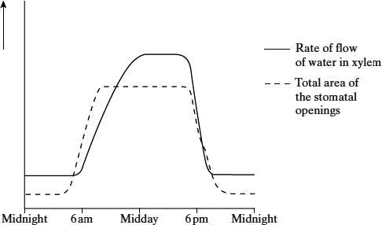

(i)      Describe the relationship between the rate of flow of water and the total area of the stomatal openings for the period of time between midday and midnight.

______________________________________________________________

______________________________________________________________

**(1)**

(ii)     Between 8 am and midday the rate of flow of water continues to rise although the total area of the stomatal openings remains constant. Explain why the rate of flow of water rises.

______________________________________________________________

**(1)**

(iii)     How would the curve showing the total area of the stomatal openings differ if the investigation was repeated on a dull day?

______________________________________________________________

______________________________________________________________

**(1)**

(c)     Some xerophytic plants have sunken stomata. Explain the advantage of this adaptation.

___________________________________________________________________

___________________________________________________________________

___________________________________________________________________

___________________________________________________________________

**(2)**

**(Total 7 marks)**

**Q4.**

(a)     The diameter of a branch of a tree and the rate of flow of water through the branch were measured over a 24-hour period. The results are shown in the graph.

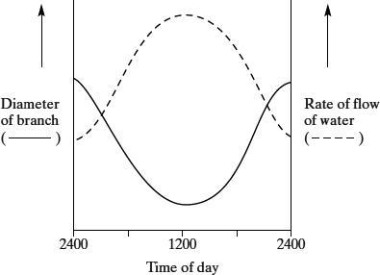

Using your knowledge of cohesion-tension theory

(i)      describe and explain the changes in rate of flow of water in the branch over the 24 hour period;

______________________________________________________________

______________________________________________________________

______________________________________________________________

______________________________________________________________

______________________________________________________________

______________________________________________________________

**(3)**

(ii)     explain why the diameter of the branch decreased during the first 12 hours.

______________________________________________________________

______________________________________________________________

**(1)**

(b)     A stem was cut from a transpiring plant. The cut end of the stem was put into a solution of picric acid, which kills plant cells. The transpiration stream continued. Suggest an explanation for this observation.

___________________________________________________________________

___________________________________________________________________

___________________________________________________________________

___________________________________________________________________

**(2)**

**(Total 6 marks)**

**Q5.**

(a)     The table shows the transpiration rate of a group of plants exposed to different humidities at a temperature of 25°C.

| **Humidity / %** | **Transpiration rate / arbitrary units** |
| --- | --- |
| 20 | 26.0 |
| 40 | 21.0 |
| 50 | 16.5 |
| 60 | 11.0 |
| 70 | 9.5 |

Describe and explain the relationship between humidity and transpiration rate.

___________________________________________________________________

___________________________________________________________________

___________________________________________________________________

___________________________________________________________________

___________________________________________________________________

___________________________________________________________________

**(3)**

(b)     The diagrams show a section through a typical leaf and a section through a leaf from a xerophytic plant. The xerophytic leaf has a lower transpiration rate than the typical leaf.

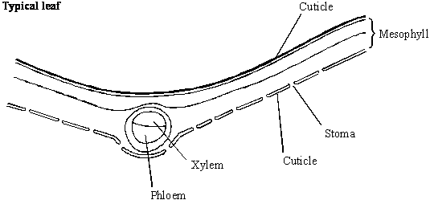

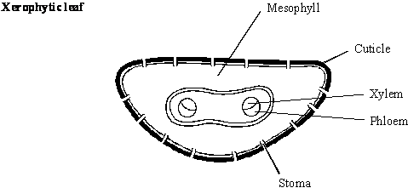

Describe **two** features shown in the diagram of the xerophytic leaf which reduce transpiration rate. Explain how each of these features contributes to a lower transpiration rate.

Feature 1___________________________________________________________

Explanation _________________________________________________________

___________________________________________________________________

Feature 2___________________________________________________________

Explanation _________________________________________________________

___________________________________________________________________

**(4)**

**(Total 7 marks)**

**Q6.**

The figure below is a photograph of a vertical section through a leaf observed using an optical microscope.

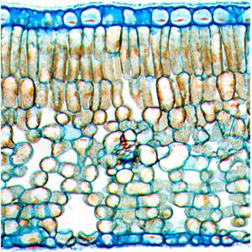

(a)  In the box below:

•   produce a scientific drawing of the arrangement of tissues shown in the figure above

•   label **one** of the tissues in your drawing

Do **not** draw individual cells.

|  |
| --- |

**(3)**

A scientist investigated factors that affect the shelf life of cut flowers.

A cut flower is the part of the stem with the flower bud attached after it has been cut from a plant.

The shelf life is the number of days the cut flowers are in good enough condition to be sold.

He:

•   took 12 cut flowers from a rose plant

•   determined the mean number of stomata per mm2 on the leaves

•   determined the transpiration rate for each cutting

•   stored the cut flowers on a shelf in a brightly lit room

•   determined the shelf life of the cut flowers.

The table below shows his results.

| **Month cut flowers were obtained** | **Mean number of stomata / mm–2 (± 2 SD)** | **Mean transpiration rate / cm3 day–1 (± 2 SD)** | **Mean shelf life / days (± 2 SD)** |
| --- | --- | --- | --- |
| December | 23  (± 2) | 22  (± 3) | 5  (± 1) |
| April | 20  (± 3) | 15  (± 2) | 16  (± 2) |

A value of ± 2 SD (standard deviations) from the mean includes over 95% of the data.

(b)  Using information in the table, what can you conclude about the effect of different factors on the mean shelf life of cut flowers?

Explain your conclusions.

___________________________________________________________________

___________________________________________________________________

___________________________________________________________________

___________________________________________________________________

___________________________________________________________________

___________________________________________________________________

___________________________________________________________________

___________________________________________________________________

___________________________________________________________________

___________________________________________________________________

___________________________________________________________________

___________________________________________________________________

**(4)**

(c)  Other than a change in temperature, give **one** change the scientist could make to the environmental conditions to increase the cut flowers’ shelf life.

Explain your answer.

___________________________________________________________________

___________________________________________________________________

___________________________________________________________________

___________________________________________________________________

___________________________________________________________________

___________________________________________________________________

___________________________________________________________________

___________________________________________________________________

___________________________________________________________________

**(3)**

**(Total 10 marks)**

**3.4.1 DNA, genes and chromosomes**

**Q1.**

The diagram shows part of a DNA molecule.

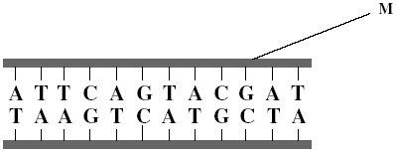

(a)     Name the **two** components of the part of the DNA molecule labelled **M**.

1. _________________________________________________________________

2. _________________________________________________________________

**(2)**

(b)     What is the maximum number of amino acids for which this piece of DNA could code?



**(1)**

(c)     Scientists calculated the percentage of different bases in the DNA from a species of bacterium. They found that 14% of the bases were guanine.

(i)      What percentage of the bases in this species of bacterium was cytosine?

Answer ____________________

**(1)**

(ii)     What percentage of the bases in this species of bacterium was adenine?

Answer ____________________

**(1)**

(d)     The scientists found that, in a second species of bacterium, 29% of the bases were guanine.

Explain the difference in the percentage of guanine bases in the two species of bacterium.

___________________________________________________________________

___________________________________________________________________

___________________________________________________________________

___________________________________________________________________

**(2)**

**(Total 7 marks)**

**Q2.**

**Figure 1** shows a short section of a DNA molecule.

**Figure 1**

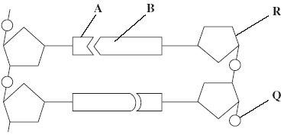

(a)     Name parts **R** and **Q**.

(i)      **R** ____________________

(ii)     **Q** ____________________

**(2)**

(b)     Name the bonds that join **A** and **B**.

___________________________________________________________________

**(1)**

(c)     Ribonuclease is an enzyme. It is 127 amino acids long.

          What is the minimum number of DNA bases needed to code for ribonuclease?



**(1)**

(d)     **Figure 2** shows the sequence of DNA bases coding for seven amino acids in the enzyme ribonuclease.

**Figure 2**

**G  T  T  T  A  C  T  A  C  T  C  T  T  C  T  T  C  T  T  T  A**

The number of each type of amino acid coded for by this sequence of DNA bases is shown in the table.

| **Amino acid** | **Number present** |
| --- | --- |
| Arg | 3 |
| Met | 2 |
| Gln | 1 |
| Asn | 1 |

Use the table and **Figure 2** to work out the sequence of amino acids in this part of the enzyme. Write your answer in the boxes below.

| Gln |  |  |  |  |  |  |
| --- | --- | --- | --- | --- | --- | --- |

**(1)**

(e)     Explain how a change in a sequence of DNA bases could result in a non-functional enzyme.

___________________________________________________________________

___________________________________________________________________

___________________________________________________________________

___________________________________________________________________

___________________________________________________________________

___________________________________________________________________

**(3)**

**(Total 8 marks)**

**Q3.**

The diagram shows a short sequence of DNA bases.

**T T T G T A T A C T A G T C T A C T T C G T T A A T A**

(a)     (i)      What is the maximum number of amino acids for which this sequence of DNA bases could code?



**(1)**

(ii)     The number of amino acids coded for could be fewer than your answer to part (a)(i).

Give **one** reason why.

______________________________________________________________

______________________________________________________________

**(1)**

(b)     Explain how a change in the DNA base sequence for a protein may result in a change in the structure of the protein.

___________________________________________________________________

___________________________________________________________________

___________________________________________________________________

___________________________________________________________________

___________________________________________________________________

___________________________________________________________________

**(3)**

(c)     A piece of DNA consisted of 74 base pairs. The two strands of the DNA, strands **A** and **B**, were analysed to find the **number** of bases of each type that were present. Some of the results are shown in the table.

|  | **Number of bases** | | | | |
| --- | --- | --- | --- | --- | --- |
|  | C | | G | A | T |
| Strand **A** | 26 | |  |  |  |
| Strand **B** | 19 | |  | 9 |  |
|  |  |  |  |  |  |

Complete the table by writing in the missing values.

**(2)**

**(Total 7 marks)**

**3.4.2 DNA and protein synthesis**

**Q1.**

(a)  What is a gene?

___________________________________________________________________

___________________________________________________________________

**(1)**

(b)  Describe how the production of messenger RNA (mRNA) in a eukaryote cell is different from the production of mRNA in a prokaryote cell.

___________________________________________________________________

___________________________________________________________________

___________________________________________________________________

___________________________________________________________________

___________________________________________________________________

___________________________________________________________________

**(2)**

(c)  Scientists produced a short, single-stranded, artificial nucleic acid, called PNA. The PNA binds to a small section of DNA.

The scientists introduced PNA into cells and discovered that these cells produced less mRNA than cells that did not contain PNA.

Suggest how PNA affected the transcription of the section of DNA.

___________________________________________________________________

___________________________________________________________________

___________________________________________________________________

___________________________________________________________________

___________________________________________________________________

___________________________________________________________________

**(2)**

(d)  Describe the role of ATP in the process of translation in protein synthesis.

___________________________________________________________________

___________________________________________________________________

___________________________________________________________________

___________________________________________________________________

___________________________________________________________________

___________________________________________________________________

**(2)**

**(Total 7 marks)**

**Q2.**

(a)  Give the **two** types of molecule from which a ribosome is made.

1  _________________________________________________________________

2  _________________________________________________________________

**(2)**

(b)  Complete the table to give **four** structural differences between a DNA molecule and an mRNA molecule.

|  | **DNA structure** | **mRNA structure** |
| --- | --- | --- |
| **1** |  |  |
| **2** |  |  |
| **3** |  |  |
| **4** |  |  |

**(4)**

**(Total 6 marks)**

**Q3.**

(a)     Complete the table to give **two** differences between DNA and RNA.

| **Difference** | **DNA** | **RNA** |
| --- | --- | --- |
| 1 |  |  |
| 2 |  |  |

**(2)**

(b)     Describe the part played by RNA in protein synthesis.

___________________________________________________________________

___________________________________________________________________

___________________________________________________________________

___________________________________________________________________

___________________________________________________________________

___________________________________________________________________

*(Extra space)* ________________________________________________________

___________________________________________________________________

___________________________________________________________________

**(3)**

**(Total 5 marks)**

**Q4.**

(a)     (i)      What is the role of RNA polymerase in transcription?

______________________________________________________________

______________________________________________________________

**(1)**

(ii)     Name the organelle involved in translation.

______________________________________________________________

**(1)**

(b)     **Figure 1** shows some molecules involved in protein synthesis.

**Figure 1**

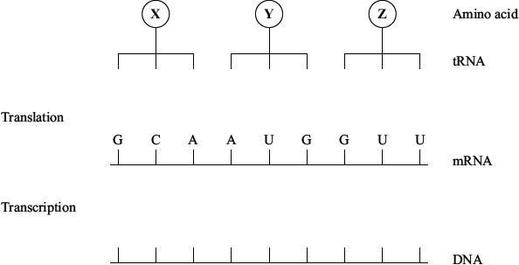

Complete **Figure 1** to show

(i)      the bases on the DNA strand from which the mRNA was transcribed;

(ii)     the bases forming the anticodons of the tRNA molecules.

**(2)**

**Figure 2** shows the effects of two different mutations of the DNA on the base sequence of the mRNA. The table shows the mRNA codons for three amino acids.

**Figure 2**

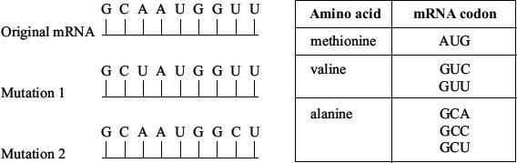

(c)     Name the type of mutation represented by mutation 1.

___________________________________________________________________

**(1)**

(d)     Use the information in the table to

(i)      identify amino acid **X** in **Figure 1**;

______________________________________________________________

**(1)**

(ii)     explain how each mutation may affect the polypeptide for which this section of DNA is part of the code.

Mutation 1 _____________________________________________________

______________________________________________________________

______________________________________________________________

______________________________________________________________

**(2)**

Mutation 2 _____________________________________________________

______________________________________________________________

______________________________________________________________

______________________________________________________________

**(2)**

**(Total 10 marks)**

**Q5.**

Lysozyme is an enzyme consisting of a single polypeptide chain of 129 amino acids.

(a)     What is the minimum number of nucleotide bases needed to code for this enzyme?

___________________________________________________________________

**(1)**

(b)     The diagram shows the sequence of bases in a section of the mRNA strand used to synthesise this enzyme.

G   G   U   C   U   U   U   C   U   U   A   U   G   G   U   A   G   A   U   A   U

(i)      Give the DNA sequence which would be complementary to the first four bases in this section of mRNA.

______________________________________________________________

**(1)**

(ii)     How many different types of tRNA molecule would attach to the section of mRNA shown in the diagram?

______________________________________________________________

**(1)**

(c)     Give **two** factors which might increase the frequency at which a mutation in DNA occurs.

1. _________________________________________________________________

2. _________________________________________________________________

**(2)**

(d)     Two single base mutations occurred in the DNA coding for this section of mRNA. These mutations caused an alteration in the sequence of amino acids in the enzyme. The diagram shows the original and altered sequences of amino acids.

| Original amino acid sequence | Gly | Leu | Ser | Tyr | Gly | Arg | Tyr |
| --- | --- | --- | --- | --- | --- | --- | --- |
| Original mRNA base sequence | GGU | CUU | UCU | UAU | GGU | AGA | UAU |

| Altered amino acid sequence | Gly | Leu | Tyr | Leu | Trp | Arg | Tyr |
| --- | --- | --- | --- | --- | --- | --- | --- |
| Altered mRNA base sequence | GGU | CUU |  |  |  | AGA | UAU |

(i)      Use the mRNA codons provided in the table to complete the altered mRNA base sequence in the diagram.

| **Amino acid** | **mRNA codons which can be used** |
| --- | --- |
| Arg | AGA |
| Gly | GGU |
| Leu | CUU or UUA |
| Ser | UCU |
| Trp | UGG |
| Tyr | UAU or UAC |

**(1)**

(ii)     Use the information provided to determine the precise nature of the **two** single base mutations in the DNA.

______________________________________________________________

______________________________________________________________

______________________________________________________________

______________________________________________________________

______________________________________________________________

______________________________________________________________

**(3)**

**(Total 9 marks)**

**Q6.**

(a)     **Figure 1** shows the exposed bases (anticodons) of two tRNA molecules involved in the synthesis of a protein.

**Figure 1**



Complete the boxes to show the sequence of bases found along the corresponding section of the coding DNA strand.

**(2)**

(b)     Describe the role of tRNA in the process of translation.

___________________________________________________________________

___________________________________________________________________

___________________________________________________________________

___________________________________________________________________

___________________________________________________________________

___________________________________________________________________

**(3)**

(c)     **Figure 2** shows the sequence of bases in a section of DNA coding for a polypeptide of seven amino acids.

**Figure 2**

TACAAGGTCGTCTTTGTCAAG

The polypeptide was hydrolysed. It contained four different amino acids. The number of each type obtained is shown in the table.

| **Amino acid** | **Number present** |
| --- | --- |
| Phe | 2 |
| Met | 1 |
| Lys | 1 |
| Gln | 3 |

Use the base sequence shown in **Figure 2** to work out the order of amino acids in the polypeptide. Write your answer in the table below.

| Met |  |  |  |  |  |  |
| --- | --- | --- | --- | --- | --- | --- |

**(2)**

**(Total 7 marks)**

**3.4.3 – Genetic diversity can arise as a result of mutation or during meiosis**

**Q1.**

(a)  Describe viral replication.

___________________________________________________________________

___________________________________________________________________

___________________________________________________________________

___________________________________________________________________

___________________________________________________________________

___________________________________________________________________

___________________________________________________________________

___________________________________________________________________

___________________________________________________________________

___________________________________________________________________

**(3)**

(b)  Complete the table below by putting a tick (**✓**) where the feature is part of a cell cycle involving mitosis or a cell cycle involving binary fission.

| **Feature** | **Cell cycle involving:** | |
| --- | --- | --- |
| **mitosis** | **binary fission** |
| Replication of linear DNA |  |  |
| Replication of circular DNA |  |  |
| Produces 2 daughter cells |  |  |
| Produces 4 daughter cells |  |  |
| Happens in prokaryotic cells |  |  |
| Happens in eukaryotic cells |  |  |

**(2)**

**Figure 1** represents a cell undergoing meiosis. It shows the chromosomes in the parent cell and in the two cells formed after the first meiotic division.

The second division of meiosis proceeds normally except that non-disjunction occurs in the chromosome labelled **N**.

**Figure 1**

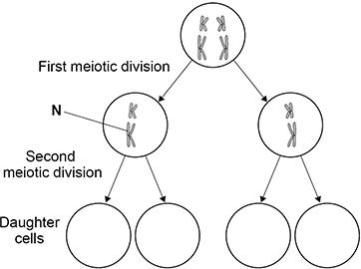

(b)  Complete **Figure 1** to show the chromosomes inside the daughter cells formed after the second meiotic division.

**(2)**

Doctors studied babies born with a mutation caused by chromosome non-disjunction during gamete formation in their mother.

They determined each mother’s age at the time of childbirth and whether the non-disjunction happened in the first meiotic division (MM1 error) or in the second meiotic division (MM2 error).

**Figure 2** shows the doctors’ results.

**Figure 2**

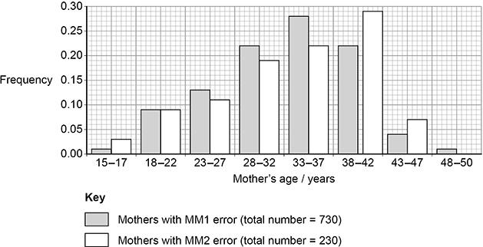

(d)  A student concluded that there were more mothers of age ˃37 with MM2 errors than with MM1 errors.

Using **Figure 2** and suitable calculations show why this conclusion is **not** valid.

___________________________________________________________________

___________________________________________________________________

**(2)**

**(Total 9 marks)**

**Q2.**

(a)  Describe how the process of meiosis results in haploid cells.

Do **not** include descriptions of how genetic variation is produced in meiosis.

___________________________________________________________________

___________________________________________________________________

___________________________________________________________________

___________________________________________________________________

___________________________________________________________________

___________________________________________________________________

___________________________________________________________________

___________________________________________________________________

___________________________________________________________________

___________________________________________________________________

___________________________________________________________________

___________________________________________________________________

**(4)**

(b)  **Figure 1** shows the arrangement of chromosomes in a cell during the first meiotic division.

**Figure 1**



A scientist observed 300 cells. All of the cells were at exactly the same stage of meiosis as the cell shown in **Figure 1**.

Use your knowledge of the independent segregation of homologous chromosomes to calculate how many of these cells are expected to have an **identical** **arrangement** of chromosomes to those shown in **Figure 1**. Assume no crossing over occurs.

Answer _______________

**(2)**

(c)  Draw a diagram to show the chromosomes in one gamete produced by meiosis from the cell shown in **Figure 1**.

**(1)**

(d)  **Figure 2** shows the life cycle of a fungus. The life cycle includes sexual reproduction.

**Figure 2**

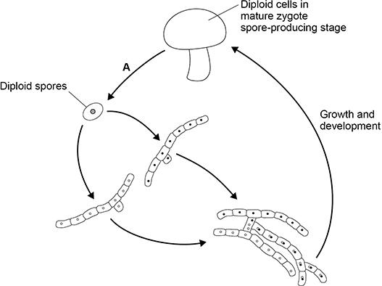

What is the name of the process shown by arrow **A** in **Figure 2**?

Tick (**✓**) **one** box.

| Binary fission |  |
| --- | --- |
| Fertilisation |  |
| Meiosis |  |
| Mitosis |  |

**(1)**

**(Total 8 marks)**

**Q3.**

(a)     Explain the importance of meiosis in the life cycles of organisms which reproduce sexually.

___________________________________________________________________

___________________________________________________________________

___________________________________________________________________

___________________________________________________________________

___________________________________________________________________

___________________________________________________________________

**(3)**

(b)     The diagram shows the life cycle of a moss plant.

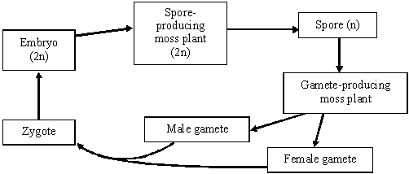

On the diagram mark with an **M** where meiosis takes place.

**(1)**

**(Total 4 marks)**

**Q4.**

(a)     During meiosis, one chromosome from each homologous pair goes to each of the cells produced. Explain why this is important.

___________________________________________________________________

___________________________________________________________________

___________________________________________________________________

___________________________________________________________________

**(2)**

(b)     The diagram shows the life cycle of a fern plant. Drawings of the chromosomes during cell division are shown for the stages that give the spore-producing plant and the gamete-producing plant.

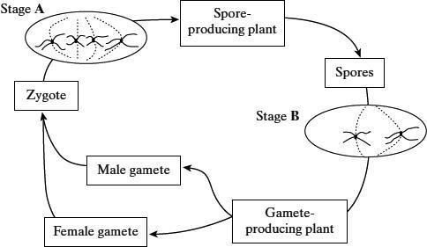

(i)      What is the diploid number of chromosomes in this fern plant?

______________________________________________________________

**(1)**

(ii)     Explain the difference in the number of chromosomes at stages **A** and **B**.

______________________________________________________________

______________________________________________________________

**(1)**

(iii)     Are the male and female gametes produced by mitosis or meiosis?

Explain your answer.

______________________________________________________________

______________________________________________________________

______________________________________________________________

______________________________________________________________

**(2)**

**(Total 6 marks)**

**Q5.**

(a)     The diagram shows a cell undergoing cell division.

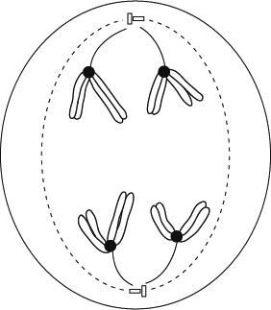

Identify the type and stage of cell division shown. Give evidence from the diagram to support your answer.

___________________________________________________________________

___________________________________________________________________

___________________________________________________________________

___________________________________________________________________

___________________________________________________________________

___________________________________________________________________

**(3)**

(b)     Describe how crossing over occurs during meiosis I.

___________________________________________________________________

___________________________________________________________________

___________________________________________________________________

___________________________________________________________________

**(2)**

**(Total 5 marks)**

**3.4.5 Species and taxonomy**

**Q1.**

Courtship and mating in fruitflies can occur equally well in the light or dark.

The diagrams show the courtship sequence of males from two closely related species of fruitfly (species **A** and species **B**). The numbers show the probability of one courtship element following from another.

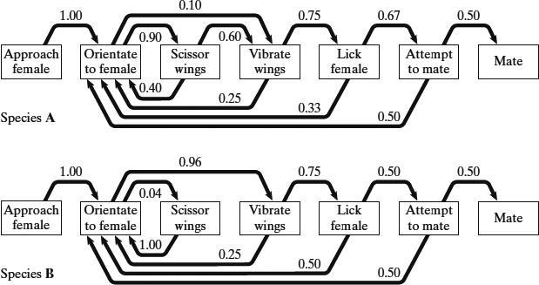

(a)     Once a male of species **A** has orientated to the female, what is the probability that he will perform each courtship element once only and then attempt to mate?   
Show your working.

Probability ____________________

**(2)**

(b)     Suggest how the courtship sequences provide evidence to support the claim that the two species are

(i)      closely related;

______________________________________________________________

______________________________________________________________

**(1)**

(ii)     separate species.

______________________________________________________________

______________________________________________________________

**(1)**

(c)     During courtship, vibration of the wings creates a sound. The sound is different in the two species of fruitfly. Explain how this prevents mating between members of different species.

___________________________________________________________________

___________________________________________________________________

___________________________________________________________________

___________________________________________________________________

**(2)**

**(Total 6 marks)**

**Q2.**

(a)     The mammals form a class called the Mammalia within the animal kingdom. The grey wolf is a species of mammal. **Figure 1** shows the groups within the Mammalia to which the wolf (labelled **W**) belongs.

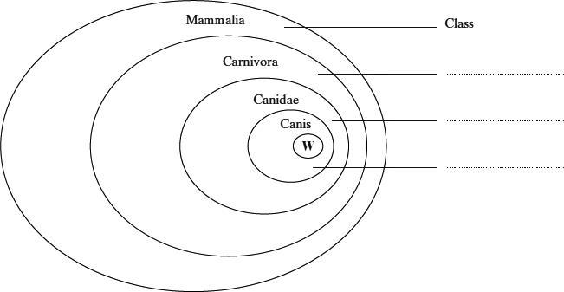

**Figure 1**

(i)      Label **Figure 1** to show the names of the groups.

**(2)**

(ii)     The lion, *Panthera leo*, belongs to another group in the Carnivora, called the Felidae. Add this information to **Figure 1**, using the letter L to represent the lion species.

**(1)**

(b)     The diagrams show two systems of classification of mammals. **Figure 2** shows a simple hierarchy. **Figure 3** shows a phylogenetic system.

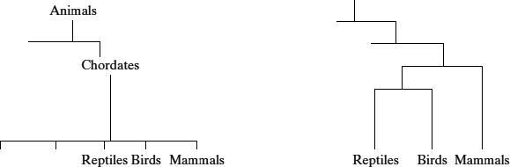

**Figure 2**                                                                    **Figure 3**

(i)      What is meant by a hierarchy?

______________________________________________________________

______________________________________________________________

**(1)**

(ii)     By reference to **Figures 2** and **3**, explain how a phylogenetic system differs from a simple hierarchy.

______________________________________________________________

______________________________________________________________

______________________________________________________________

______________________________________________________________

______________________________________________________________

______________________________________________________________

**(3)**

**(Total 7 marks)**

**Q3.**

(a)  Describe how organisms are grouped in a phylogenetic classification system.

___________________________________________________________________

___________________________________________________________________

___________________________________________________________________

___________________________________________________________________

**(2)**

**Table 1** shows some of the taxa in the phylogenetic classification of a rhinoceros species.

| **Table 1** | |
| --- | --- |
| **Taxon name** | **Scientific name** |
| Class | Mammalia |
| Order | Perissodactyla |
| Family | Rhinocerotidae |
| Genus | *Rhinoceros* |
| Species | *unicornis* |

The figure below shows the relationship between the taxa in the classification of two rhinoceros species: *Rhinoceros unicornis* and *Dicerorhinus sumatrensis*.

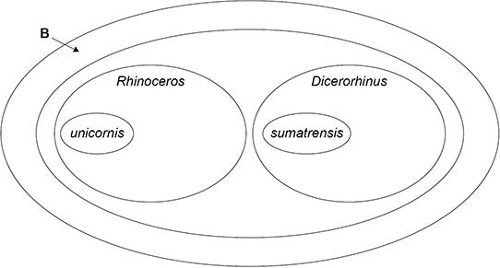

(b)  Use information in **Table 1** to give the **scientific** name of the taxon labelled **B** in the figure above.

___________________________________________________________________

**(1)**

(c)  Draw an oval on the figure above to show the species *Rhinoceros sondaicus*.

**(1)**

Scientists investigated a phylogenetic relationship between individuals of five species of rhinoceros.

The scientists:

•   determined the DNA base sequence of the *cyt b* gene of each rhinoceros

•   compared each *cyt b* DNA base sequence with that of **one** Indian rhinoceros (called the reference rhinoceros)

•   calculated the percentage difference between each *cyt b* DNA base sequence and that of the reference rhinoceros.

**Table 2** shows their results.

| **Table 2** | |
| --- | --- |
| **Investigated species of rhinoceros** | **Percentage difference in DNA base sequences compared with the reference Indian rhinoceros** |
| Indian | 2 |
| Javan | 5 |
| Sumatran | 13 |
| White | 14 |
| Black | 14 |

(d)  What can you conclude about the likely phylogenetic relationships between these species? Evaluate your conclusion.

___________________________________________________________________

___________________________________________________________________

___________________________________________________________________

___________________________________________________________________

___________________________________________________________________

___________________________________________________________________

___________________________________________________________________

___________________________________________________________________

___________________________________________________________________

___________________________________________________________________

___________________________________________________________________

**(4)**

(e)  A scientist obtained a rhinoceros horn confiscated from poachers and wanted to identify the species of rhinoceros that was killed for its horn.

He used the procedure described in part (d) and calculated the difference in *cyt b* DNA as 14%.

What can you conclude from this result? Explain your answer.

Suggest a change to the procedure that will more precisely identify the rhinoceros species that provided the horn.

Conclusion and explanation  ___________________________________________

___________________________________________________________________

___________________________________________________________________

___________________________________________________________________

Suggested change to the procedure  _____________________________________

___________________________________________________________________

___________________________________________________________________

___________________________________________________________________

**(2)**

**(Total 10 marks)**

**Q4.**

(a)     Explain the principles which biologists use to classify organisms into groups.

___________________________________________________________________

___________________________________________________________________

___________________________________________________________________

___________________________________________________________________

___________________________________________________________________

___________________________________________________________________

**(3)**

Cytochrome c is a protein with about 100 amino acids and is present in all eukaryotic organisms. It has the same three-dimensional shape in all species, but only 30 of the amino acids are the same in all species. The amino acid sequence of cytochrome c has been used to construct the phylogenetic tree shown below.

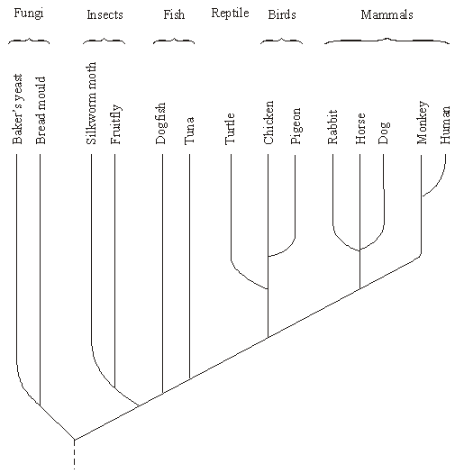

(b)     Name the kingdoms represented in this phylogenetic tree.

___________________________________________________________________

**(1)**

(c)     What does the phylogenetic tree show about the evolutionary relationship between fungi and insects?

___________________________________________________________________

___________________________________________________________________

___________________________________________________________________

___________________________________________________________________

**(2)**

(d)     Suggest how information on amino acid sequences is used to construct a phylogenetic tree.

___________________________________________________________________

___________________________________________________________________

___________________________________________________________________

___________________________________________________________________

**(2)**

(e)     Suggest **one** advantage and **one** disadvantage of using cytochrome c to construct a phylogenetic tree.

Advantage

___________________________________________________________________

___________________________________________________________________

Disadvantage

___________________________________________________________________

___________________________________________________________________

**(2)**

**(Total 10 marks)**

**3.4.6 – Biodiversity within a Community**

**Q1.**

Parts of the sea shore form a very hostile environment for living organisms. Twice each day the incoming and outgoing tides alternately cover the organisms on the sea shore with water and then leave them exposed. The force of the waves could also dislodge any organisms that were not firmly attached.

The diagram shows a section through a rocky shore. Two sites were studied: site **A** was on the upper shore and site **B** on the lower shore.

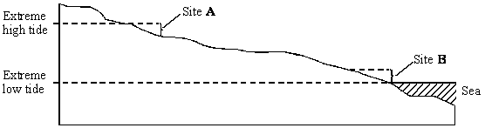

The table shows the seaweeds that were found growing at sites **A** and **B**.

| **Site A: upper shore** | **Mean number per m2** | **Site B: lower shore** | **Mean number per m2** |
| --- | --- | --- | --- |
| *Ascophyllum nodosum Fucus spiralis Fucus vesiculosus Pelvetia canaliculata* | 2 10 4 6 | *Corallina officinalis Fucus serratus Laminaria digitata Laminaria hyperborea Laminaria saccharina Laurencia pinnatifida Palmaria palmata* | 31 8 15 3 6 18 6 |
| Index of diversity |  | Index of diversity | 4.77 |

(a)     (i)      Use the formula 

where       **d** = index of diversity  
**N** = total number of organisms of all species  
**n** = total number of organisms of a particular species

to calculate the index of diversity for the seaweeds growing at site **A**.  
Show your working.

Index of diversity at site **A** = ____________________

**(2)**

(ii)     Give **one** advantage of calculating the index of diversity rather than just recording the number of species present.

______________________________________________________________

______________________________________________________________

**(1)**

(b)     Availability of water is one abiotic factor which determines the distribution of seaweeds. The graph shows loss in mass due to water evaporation for two of the seaweed species. The two seaweeds belong to the same genus but one was found only on the upper shore and the other only on the lower shore.

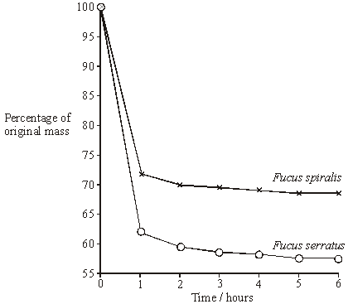

Explain how the results shown in the graph relate to the distribution of these two seaweeds on the sea shore.

___________________________________________________________________

___________________________________________________________________

___________________________________________________________________

___________________________________________________________________

___________________________________________________________________

**(3)**

**(Total 6 marks)**

**Q2.**

(a)     What information is required to calculate an index of diversity for a particular community?

___________________________________________________________________

___________________________________________________________________

___________________________________________________________________

**(1)**

(b)     Farmers clear tropical forest and grow crops instead. Explain how this causes the diversity of insects in the area to decrease.

___________________________________________________________________

___________________________________________________________________

___________________________________________________________________

___________________________________________________________________

___________________________________________________________________

___________________________________________________________________

**(3)**

Farmers manage the ditches that drain water from their fields. If they do not, the ditches will become blocked by plants. Biologists investigated the effects of two different ways of managing ditches on farmland birds.

•        Ditch **A** was cleared of plants on both banks

•        Ditch **B** was cleared of plants on one bank.

The graph shows the number of breeding birds of all species along the two ditches, before and after management.

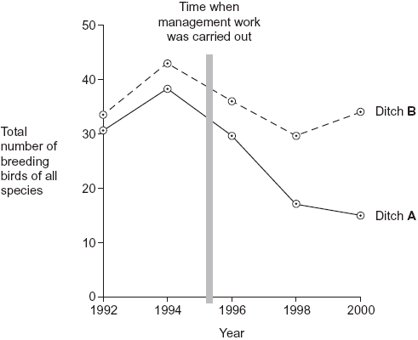

(c)     (i)      The points on the graph have been joined with straight lines rather than with a smooth curve. Explain why they have been joined with straight lines.

______________________________________________________________

______________________________________________________________

______________________________________________________________

**(1)**

(ii)     It would have been useful to have had a control ditch in this investigation. Explain why.

______________________________________________________________

______________________________________________________________

______________________________________________________________

**(1)**

(d)     A farmer who wanted to increase the diversity of birds on his land read about this investigation.

He concluded that clearing the plants from one bank would not decrease diversity as much as clearing the plants from both banks. Evaluate this conclusion.

___________________________________________________________________

___________________________________________________________________

___________________________________________________________________

___________________________________________________________________

___________________________________________________________________

___________________________________________________________________

**(3)**

**(Total 9 marks)**

**Q3.**

(a)     A student investigated the diversity of plants at several sites on a golf course. At each site she took a large number of random samples.

(i)      Explain the importance of taking a large number of samples at each site.

______________________________________________________________

______________________________________________________________

______________________________________________________________

**(1)**

(ii)     Explain the importance of taking samples at random.

______________________________________________________________

______________________________________________________________

______________________________________________________________

**(1)**

The student collected data from one part of the golf course and calculated an index of diversity.

The table shows her data.

| **Species** | **Number of plants per m2** |
| --- | --- |
| Sheep’s fescue | 11 |
| Creeping buttercup | 6 |
| Clover | 5 |
| Dandelion | 2 |
| Sheep’s sorrel | 1 |
| Lady’s bedstraw | 7 |
| Stemless thistle | 4 |

The index of diversity can be calculated from the formula



where

*d*  =  index of diversity  
*N*  = total number of organisms of all species  
*n*  =  total number of organisms of each species

(b)     Use the formula to calculate the index of diversity for the plants on this part of the golf course. Show your working.

Answer ____________________

**(2)**

(c)     The golf course was surrounded by undeveloped grassland from which it had been produced.  
The golf course had

•        some areas of very short grass which was cut frequently

•        some areas of longer grass which was cut less frequently

•        some areas of long grass and shrubs which were never cut.

The index of diversity for the insects on the golf course was higher than that for the surrounding undeveloped grassland.

Explain the effect of developing this golf course on the index of diversity of insects.

___________________________________________________________________

___________________________________________________________________

___________________________________________________________________

___________________________________________________________________

___________________________________________________________________

___________________________________________________________________

**(3)**

**(Total 7 marks)**

**Q4.**

Scientists investigated the species of insects found in a wood and in a nearby wheat field. The scientists collected insects by placing traps at sites chosen at random both in the wood and in the wheat field.

The table shows the data collected in the wood and in the wheat field.

| **Species of insect** | **Number of organisms of each species** | |
| --- | --- | --- |
| **Wood** | **Wheat field** |
| Bird-cherry oat aphid | 0 | 216 |
| Beech aphid | 563 | 0 |
| Large white butterfly | 20 | 0 |
| Lacewing | 12 | 3 |
| 7-spot ladybird | 36 | 0 |
| 2-spot ladybird | 9 | 1 |
| Total number of organisms of all species | 640 | 220 |

(a)     The scientists collected insects at sites chosen at random. Explain the importance of the sites being chosen at random.

___________________________________________________________________

___________________________________________________________________

___________________________________________________________________

**(1)**

(b)     (i)      Use the formula



to calculate the index of diversity for the insects caught in the wood, where

*d* = index of diversity  
*N* = total number of organisms of all species  
*n* = total number of organisms of each species

Show your working.

Answer ____________________

**(2)**

(ii)     Without carrying out any further calculations, estimate whether the index of diversity for the wheat field would be higher or lower than the index of diversity for the wood.

Explain how you arrived at your answer.

______________________________________________________________

______________________________________________________________

______________________________________________________________

______________________________________________________________

______________________________________________________________

**(2)**

(c)     A journalist concluded that this investigation showed that farming reduces species diversity.  
Evaluate this conclusion.

___________________________________________________________________

___________________________________________________________________

___________________________________________________________________

___________________________________________________________________

___________________________________________________________________

**(2)**

(d)     Farmers were offered grants by the government to plant hedges around their fields.  
Explain the effect planting hedges could have on the index of diversity for animals.

___________________________________________________________________

___________________________________________________________________

___________________________________________________________________

___________________________________________________________________

___________________________________________________________________

**(2)**

**(Total 9 marks)**

**Required Practical 2 - Mitosis**

**Q1.**

A student prepared a stained squash of cells from the root tips of garlic to calculate a mitotic index. He:

**1.**   cut the end 5 mm from 10 garlic roots

**2.**   placed the root tips into a Petri dish containing 5 cm3 of hydrochloric acid for 12 minutes

**3.**   rinsed the root tips in distilled water

**4.**   placed one of the root tips on a microscope slide and added toluidine blue stain

**5.**   placed a coverslip onto the microscope slide, and gently pressed the coverslip downwards on the root tip

**6.**   observed the root tip using an optical microscope.

(a)  Suggest why the student soaked the root tips in hydrochloric acid in step **2**.

___________________________________________________________________

___________________________________________________________________

___________________________________________________________________

___________________________________________________________________

___________________________________________________________________

___________________________________________________________________

___________________________________________________________________

___________________________________________________________________

**(2)**

(b)  Pressing the coverslip downwards enabled the student to observe the stages of mitosis clearly.

Explain why.

___________________________________________________________________

___________________________________________________________________

___________________________________________________________________

___________________________________________________________________

___________________________________________________________________

___________________________________________________________________

___________________________________________________________________

**(2)**

The diagram below shows the student’s drawing of one field of view.



(c)  Name the stage of mitosis shown in cell **G**. Explain the appearance of this cell.

Stage of mitosis  _____________________________________________________

Explanation  ________________________________________________________

___________________________________________________________________

___________________________________________________________________

___________________________________________________________________

___________________________________________________________________

**(2)**

(d)  Use the diagram above to calculate a mitotic index for the cells in this field of view.

Mitotic index ____________________

**(1)**

(e)  Other students in the class followed the same method, but calculated different mitotic indices.

Apart from student errors, suggest **two** explanations why.

1  _________________________________________________________________

___________________________________________________________________

___________________________________________________________________

2  _________________________________________________________________

___________________________________________________________________

___________________________________________________________________

**(2)**

**(Total 9 marks)**

**Q2.**

(a)     A student prepared a stained squash of cells from the tip of an onion root and observed it using an optical microscope.

During the preparation of the slide, he:

•        cut the first 5 mm from the tip of an onion root and placed it on a glass slide

•        covered this tip with a drop of stain solution and a cover slip

•        warmed the glass slide

•        pressed down firmly on the cover slip.

He identified and counted nuclei in different stages of the cell cycle.

Explain why the student:

1. used only the first 5 mm from the tip of an onion root.

___________________________________________________________________

___________________________________________________________________

___________________________________________________________________

___________________________________________________________________

___________________________________________________________________

2. pressed down firmly on the cover slip.

___________________________________________________________________

___________________________________________________________________

___________________________________________________________________

___________________________________________________________________

___________________________________________________________________

**(2)**

**Figure 1** shows the cells the student saw in one field of view. He used this field of view to calculate the length of time these onion cells spent in anaphase of mitosis.

**Figure 1**

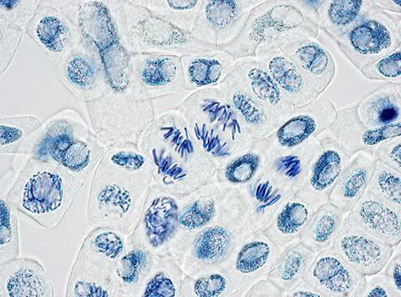

(b)     Scientists have found the mean length of time spent by onion cells in anaphase of mitosis is 105 minutes. They also found the cell cycle of cells in the onion root shown in **Figure 1** takes 1080 minutes.

32 whole cells are shown in **Figure 1**.

Use this information and **Figure 1** to calculate the length of time the cells of this onion root are in anaphase **and** then calculate the percentage difference between your answer and the mean length of time found by the **scientists**.

Show your working.

Answer = ____________________ %

**(2)**

(c)     Tick (**✓**) the name given to the division of cytoplasm during the cell cycle.

| **A** | Binary fission |  |
| --- | --- | --- |
| **B** | Cytokinesis |  |
| **C** | Phagocytosis |  |
| **D** | Segregation |  |

**(1)**

(d)     Describe and explain what the student should have done when counting cells to make sure that the mitotic index he obtained for this root tip was accurate.

___________________________________________________________________

___________________________________________________________________

___________________________________________________________________

___________________________________________________________________

___________________________________________________________________

___________________________________________________________________

___________________________________________________________________

___________________________________________________________________

___________________________________________________________________

___________________________________________________________________

**(2)**

(e)     A scientist treated growing tips of onion roots with a chemical that stops roots growing. After 24 hours, he prepared a stained squash of these root tips.

**Figure 2** is a drawing showing the chromosomes in a single cell observed in the squash of one of these root tips in anaphase. This cell was typical of other cells in anaphase in these root tips.

**Figure 2**

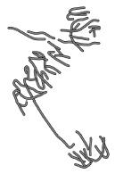

Use all of this information to suggest how the chemical stops the growth of roots.

___________________________________________________________________

___________________________________________________________________

___________________________________________________________________

___________________________________________________________________

___________________________________________________________________

___________________________________________________________________

___________________________________________________________________

___________________________________________________________________

___________________________________________________________________

___________________________________________________________________

___________________________________________________________________

___________________________________________________________________

___________________________________________________________________

___________________________________________________________________

**(3)**

**(Total 10 marks)**

**Q3.**

A student investigated the stages of mitosis in a garlic root. The root tip was placed on a microscope slide with a stain. A cover slip was placed on top and the root tip was firmly squashed.

(a)     Explain why

(i)      a root tip was used;

______________________________________________________________

______________________________________________________________

**(1)**

(ii)     a stain was used;

______________________________________________________________

______________________________________________________________

**(1)**

(iii)     the root tip was firmly squashed.

______________________________________________________________

______________________________________________________________

**(1)**

(b)     The student examined the cells in the garlic root tip under the microscope, and obtained the following data.

| **Stage** | **Number of cells** |
| --- | --- |
| Interphase | 872 |
| Prophase | 74 |
| Metaphase | 18 |
| Anaphase | 10 |
| Telophase | 8 |

(i)      Calculate the percentage of these cells in which the chromosomes are visible and would consist of a pair of chromatids joined together. Show your working.

Answer ____________________

**(2)**

(ii)     A different set of results was obtained when the count was repeated on another occasion with a different garlic root tip. Give **two** reasons for the difference in results.

1. ____________________________________________________________

______________________________________________________________

2. ____________________________________________________________

______________________________________________________________

**(2)**

**(Total 7 marks)**

**Required practical 6 – Aseptic technique**

**Q1.**

A student investigated the effect of three types of disinfectant on the growth of *Lactobacillus* bacteria.

During the investigation, the student:

•   boiled the agar before pouring the agar plates

•   transferred 0.5 cm3 of a diluted liquid culture of *Lactobacillus* onto each agar plate

•   left some agar plates as controls

•   added to other agar plates different concentrations of the disinfectants as shown in the table in part (a).

After 2 days, she counted the number of colonies of bacteria on each agar plate.

(a)     Explain the purpose of:

boiling the agar ______________________________________________________

___________________________________________________________________

___________________________________________________________________

___________________________________________________________________

transferring the same volume of liquid culture onto each agar plate.

___________________________________________________________________

___________________________________________________________________

___________________________________________________________________

___________________________________________________________________

**(2)**

The three disinfectants used by the student were Lysol, propan-2-ol and ammonia.

The table shows the student’s results.

| **Concentration of disinfectant / arbitrary units** | **Number of colonies of bacteria** | | |
| --- | --- | --- | --- |
| **Lysol** | **Propan-2-ol** | **Ammonia** |
| 0 | 300 | 300 | 300 |
| 5 | 0 | 290 | 300 |
| 10 | 0 | 195 | 295 |
| 15 | 0 | 0 | 275 |
| 20 | 0 | 0 | 240 |

The liquid culture the student transferred was diluted by 1 in 10 000 (10−4).

(b)     Use information in this question to calculate how many bacteria were present in 1 cm3 of undiluted liquid culture.

Answer = ____________________

**(2)**

(c)     The student concluded that the minimum concentration of propan-2-ol needed to stop the growth of *Lactobacillus* was 15 units. This conclusion is incorrect.

Describe how you could obtain a more accurate estimate of the minimum concentration of propan-2-ol needed to stop the growth of this species of bacterium.

___________________________________________________________________

___________________________________________________________________

___________________________________________________________________

___________________________________________________________________

___________________________________________________________________

___________________________________________________________________

___________________________________________________________________

**(2)**

**(Total 6 marks)**

**Q2.**

(a)     Name the process by which bacterial cells divide.

___________________________________________________________________

**(1)**

A microbiologist investigated the ability of different plant oils to kill the bacterium *Listeria monocytogenes*. She cultured the bacteria on agar plates. She obtained the bacteria from a broth culture.

(b)     Describe **two** aseptic techniques she would have used when transferring a sample of broth culture on to an agar plate.

Explain why each was important.

___________________________________________________________________

___________________________________________________________________

___________________________________________________________________

___________________________________________________________________

___________________________________________________________________

___________________________________________________________________

___________________________________________________________________

___________________________________________________________________

___________________________________________________________________

___________________________________________________________________

___________________________________________________________________

___________________________________________________________________

**(4)**

The microbiologist tested five different plant oils at two different temperatures and determined the minimum concentration of plant oil that killed the *L. monocytogenes*.

The table below shows her results.

| **Plant oil** | **Minimum concentration of plant oil that killed *Listeria monocytogenes* / percentage** | |
| --- | --- | --- |
| **4 °C** | **35 °C** |
| **Bay** | 0.10 | 0.04 |
| **Cinnamon** | 0.08 | 0.08 |
| **Clove** | 0.05 | 0.05 |
| **Nutmeg** | >1.00 | 0.05 |
| **Thyme** | 0.02 | 0.03 |

(c)     Which plant oil is least effective at killing *L. monocytogenes* at 35 °C?

___________________________________________________________________

**(1)**

*L. monocytogenes* is a pathogen of great concern to the food industry, especially in foods stored in refrigeration conditions (4 °C) where, unlike most food-borne pathogens, it is able to multiply. It has been suggested that plant oils, together with refrigeration may help to reduce the growth of *L. monocytogenes*.

(d)     What conclusions can be drawn about the effectiveness of using plant oils with refrigeration to reduce food-borne infections caused by *L. monocytogenes*?

___________________________________________________________________

___________________________________________________________________

___________________________________________________________________

___________________________________________________________________

___________________________________________________________________

___________________________________________________________________

**(3)**

(e)     Plant oils are hydrophobic and can cross the cell-surface membrane of the bacterium. The low temperature of 4 °C can slow the rate of entry of plant oils into the cells.

Suggest how the low temperature slows the rate of entry.

___________________________________________________________________

___________________________________________________________________

___________________________________________________________________

**(1)**

**(Total 10 marks)**

**Q3.**

An agar plate was flooded with a culture of a species of bacterium usually found in the mouth. Four sterile paper discs, **A**, **B**, **C** and **D**, each containing a different brand of mouthwash, were then placed on the agar plate. The drawing shows the appearance of the plate after it had been incubated at 37°C for three days.

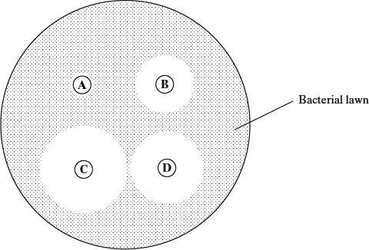

(a)     Describe the aseptic techniques that would be used when flooding the agar plate with bacteria.

___________________________________________________________________

___________________________________________________________________

___________________________________________________________________

___________________________________________________________________

___________________________________________________________________

___________________________________________________________________

**(3)**

(b)     The effectiveness of a mouthwash can be measured by calculating the total area of a paper disc and the clear zone around it. The area of a circle is given by *πr*2, where *r* is the radius of the circle. Calculate how many times more effective mouthwash **C** is than mouthwash **B**. Show your working.

Mouthwash **C** is _________________ times more effective than mouthwash **B**.

**(2)**

(c)     Several factors affect the rate at which the antiseptic in the mouthwash from each paper disc diffuses through the agar. Describe the effect of **three** named factors on this rate.

1. _________________________________________________________________

___________________________________________________________________

2. _________________________________________________________________

___________________________________________________________________

3. _________________________________________________________________

___________________________________________________________________

**(3)**

**(Total 8 marks)**

**Q4.**

(a)  *Clostridium difficile* is a bacterial species that causes disease in humans.

Antibiotic-resistant strains of *C. difficile* have become a common cause of infection acquired when in hospital.

Explain how the use of antibiotics has led to antibiotic-resistant strains of bacteria becoming a common cause of infection acquired when in hospital.

___________________________________________________________________

___________________________________________________________________

___________________________________________________________________

___________________________________________________________________

___________________________________________________________________

___________________________________________________________________

___________________________________________________________________

___________________________________________________________________

___________________________________________________________________

___________________________________________________________________

___________________________________________________________________

___________________________________________________________________

**(3)**

(b)  Scientists suggested that factors, other than antibiotic use, led to the increase in antibiotic-resistant *C. difficile* infections. One suggested factor is people eating more trehalose in their diet.

Trehalose is a disaccharide formed from two glucose molecules.

Name another disaccharide formed from two glucose molecules.

___________________________________________________________________

**(1)**

Scientists investigated the effect of trehalose on the growth rate of *C. difficile*.

They grew populations of non-resistant and antibiotic-resistant *C. difficile* on separate agar plates with:

•   no carbohydrate added

•   trehalose added.

They measured the growth rate of the *C. difficile*.

The graph below shows the scientists’ results.

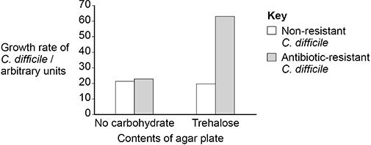

(c)  Describe how the scientists could use aseptic techniques to transfer 0.3 cm3 of *C. difficile* in liquid culture from a bottle onto an agar plate.

___________________________________________________________________

___________________________________________________________________

___________________________________________________________________

___________________________________________________________________

___________________________________________________________________

___________________________________________________________________

___________________________________________________________________

___________________________________________________________________

___________________________________________________________________

___________________________________________________________________

___________________________________________________________________

___________________________________________________________________

**(3)**

(d)  Use the graph above to evaluate whether more trehalose in the diet could be a factor in the increased number of antibiotic-resistant *C. difficile* infections.

___________________________________________________________________

___________________________________________________________________

___________________________________________________________________

___________________________________________________________________

___________________________________________________________________

___________________________________________________________________

___________________________________________________________________

___________________________________________________________________

___________________________________________________________________

___________________________________________________________________

___________________________________________________________________

___________________________________________________________________

**(3)**

**(Total 10 marks)**

**MS1.2 Find arithmetic means**

**Q1.**

(a)     In the UK in 2016, there were 525 048 deaths. Cancer caused 30.4% of all deaths. Throat cancer caused 5% of all deaths from cancer.

Calculate the mean number of people who died of throat cancer per month in 2016.

Show your working.

Answer _______________ people per month

**(2)**

**Q2.**

(a)     One of the different types of air was similar to the air in the meadow where the grasshoppers were collected. It provides data that might be used to calculate a mean breathing rate for grasshoppers in the meadow.

(i)      Use the data to estimate the mean breathing rate of the three grasshoppers in the meadow. Show your working.

Mean breathing rate = ____________________ breaths per minute

**(2)**

**Q3.**

(a)     At 30 °C, one student obtained the following results.

| Volume of gas collected in 5 minutes / cm3 | Result 1 | Result 2 | Result 3 |
| --- | --- | --- | --- |
| 38.3 | 27.6 | 29.4 |

Calculate the mean rate of gas production. Give your answer in cm3 s–1.

Answer ____________________ cm3 s–1

**(2)**

**MS1.4 Understand simple probability**

**Q1.**

(a)  A scientist used an optical microscope to determine the mitotic index in cells at different distances from the tip of onion roots.

The graph below shows the results.

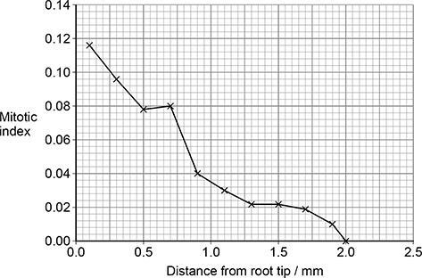

Complete the word equation used to determine each mitotic index in the graph above.

Mitotic Index =

**(1)**

(b)  The scientist used data from the graph above to calculate a correlation coefficient (r). The scientist then used a statistical test to determine the probability (P) associated with the value of r.

r = –0.98 (P < 0.05)

What can you conclude from this result?

___________________________________________________________________

___________________________________________________________________

___________________________________________________________________

___________________________________________________________________

___________________________________________________________________

___________________________________________________________________

**(2)**

**Q2.**

A medical officer investigated the effectiveness of five different types of influenza vaccine. A total of 1350 people agreed to be vaccinated. The medical officer divided these into five groups. The number who suffered from influenza in the following year was recorded. The results are shown in the table.

|  | **Number of people vaccinated** | | | |
| --- | --- | --- | --- | --- |
| **Type of influenza vaccine** | **Suffered from influenza** | **Did not suffer from influenza** | **Total** | **Proportion suffering from influenza** |
| I | 43 | 237 | 280 | 0.15 |
| II | 52 | 198 | 250 | 0.21 |
| III | 25 | 245 | 270 | 0.09 |
| IV |  |  | 260 | 0.18 |
| V | 57 | 233 | 290 | 0.20 |

(a)     Complete the spaces in the table for the people vaccinated with type IV vaccine.

**(1)**

(b)     The medical officer used a statistical test to assess the effectiveness of the five different vaccines.

(i)      What would be the null hypothesis?

______________________________________________________________

______________________________________________________________

**(1)**

(ii)     The statistical test gave a probability of less than 0.05. What conclusion can be drawn from this?

______________________________________________________________

______________________________________________________________

**(1)**

**MS1.9 Select and use statistical test**

**Q1.**

(a)  Scientists determined the mean mitotic index at 50 μm intervals away from the root tip in 10 young plant roots.

The graph below shows the scientists’ results.

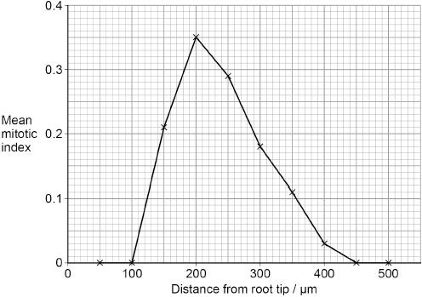

State the null hypothesis for this investigation.

Name the statistical test needed to determine whether the difference between the mean mitotic index at 200 μm and at 300 μm is significant.

Null hypothesis  ______________________________________________________

___________________________________________________________________

___________________________________________________________________

Statistical test  _______________________________________________________

**(2)**

**Q2.**

(a)  Name the statistical test you should use to determine if the observed frequencies of the four phenotypes differed significantly from the frequencies expected according to the Hardy–Weinberg equation.

State how many degrees of freedom should apply.

Statistical test  _____________________________________________________

Number of degrees of freedom  _______________________________________

**(2)**

**Q3.**

(a)     The student could determine the median, mode and range from his measurement of shell heights in these populations.

Give **two** other statistical values the student could calculate from his measurement of shell heights in these populations.

1   ___________________________________

2   ___________________________________

**(1)**

**Q4.**

Scientists measured the mean amino acid concentration in white wines made from grapes grown organically and white wines made from grapes that were not grown organically.

(a)     The scientists used a statistical test to determine whether there was a significant difference in the amino acid concentration in the two types of white wine. They obtained a value for P of 0.04.

Name the statistical test the scientists used and give a reason for your answer.

Was the difference significant? Give a reason for your answer.

Name of statistical test ________________________________________________

Reason for choice ____________________________________________________

___________________________________________________________________

___________________________________________________________________

Explanation of test result _______________________________________________

___________________________________________________________________

___________________________________________________________________

___________________________________________________________________

___________________________________________________________________

___________________________________________________________________

**(3)**

**MS4.1 Calculate the circumferences, surface areas and volumes of regular shapes**

**Q1.**

Scientists investigated the activation of T lymphocytes.

The scientists studied two types of cell:

•   naïve T cells, which are T cells that have not yet been in contact with a foreign antigen

•   activated helper T cells, which are T cells that have been activated by a foreign antigen.

The figure below shows electron microscope images of the two types of cell.

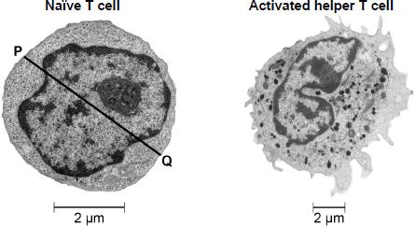

The activated helper T cell has a volume of 463 μm3

(a)  Calculate the volume of the naïve T cell shown in the figure.

Then calculate how many times larger the activated helper T cell volume is compared with the naïve T cell volume.

Assume the cell is spherical.

Use line **PQ** to measure the diameter of the naïve T cell.

Volume of a sphere = *πr*3 where *π* is 3.14

Show your working.

Volume of naïve T cell  ____________________ μm3

Number of times larger the activated helper T cell

volume is compared with the naïve T cell volume  ____________________

**(3)**

**Q2.**

(a)  An ileum cell **without** microvilli has 7.85 µm2 of cell surface in contact with digested substances.

A scientist found an ileum cell with 1000 microvilli. The microvilli cover the entire cell surface in contact with digested substances.

Microvilli are 0.1 μm in diameter and 1 μm in length.

The surface area of a microvillus is calculated using this equation

2 *π*rl + *π*r2

where *π* is 3.14,

r is the radius,

l is the length.

Calculate the ratio of the area of the ileum cell surface **with** microvilli to the area of ileum cell surface **without** microvilli.

Show your working.

Ratio _______________ :1

**(2)**

**Q3.**

**Figure 3** shows further information about a channel formed in the cell-surface membrane by the APs.

**Figure 3**

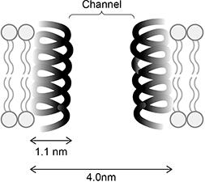

(d)  Use **Figure 3** to calculate the cross-sectional area of the channel through which ions can pass.

Assume the cross-sectional area is circular.

Use *π* = 3.14 in your calculation. Give your answer in nm2 **and** to 1 decimal place.

Answer _______________ nm2

**(2)**