**Business Studies Year 12- 13 Summer Task**

**Name…………………………………**

1. Create a revision booklet on the following theories/ topics. It should include name of theorist, image of model if necessary, key points of theory, topic area (unit) relevant to, limitations of the theory. The more detail, the better this will help your revision for year 13 exams (no copy and paste)

Topics including:

∙ Scientific Management

∙ PED

∙ YED

∙ Market Mapping

∙ Boston Matrix

∙ Product Life Cycle

∙ Hertzberg

∙ Stock Control Charts

∙ Maslow

∙ Taylor

1. **Year 13 preparation**

**Ansoff’s Matrix**

Ansoff is widely known for his writing on the topic of Strategic Management. His most famous theory is his matrix which considers the strategic alternatives that a firm can adopt.



Current products

Current markets

New markets

|  |  |
| --- | --- |
| Market penetration | Product development |
| Market development | Diversification |

The matrix is essentially a planning tool which provides the firm with four alternative marketing strategies. These depend upon whether they’re looking at developing new or existing markets and whether the product in question is a new or existing one. The four strategies are called:

• Market penetration

• Product development

• Market expansion

• Diversification,

1. Market penetration

This strategy is where the firm seeks to achieve growth with existing products in their existing market segments. The aim of this strategy is to increase the market share of the product in its current form. This is often achieved by simply selling more existing products to existing customers, perhaps through a price reduction or discovering new customers within existing market segments. This marketing strategy carries little risk for the firm.

1. Product development

Product development is a strategy where the firm aims to develop new products in existing market segments. This involves undertaking market research to discover how to meet existing customer’s needs more successfully. There might need to be investment in research and development which will initially be a drain on profits. An example of this product development is how Nestle have developed various types of Polo Mints. There is a moderate degree of risk associated with this strategy.

1. Market expansion

If a firm deploys a market development strategy it looks to take existing products and target them at a different market segment. In other words, the firm aims to discover new markets for existing products in its portfolio. An example of this is Lucozade which extended the target market for its glucose drink from simply children who were feeling sick towards fit and healthy children and adults engaged in playing sport. As with product development, there is a moderate degree of risk associated with this strategy.

1. Diversification

The final alternative is diversification. Here the firm is introducing new products into new markets. This is the strategy which carries the most risk as the firm cannot rely on its past experiences within the market. However, it might be argued that diversification allows a firm to spread risk across different products within varied markets. An example of a firm employing this strategy is the Virgin Group which has a presence in markets as varied as train operating, soft drinks, music, gyms, banking, mobile communications and airlines.

TASK: Apply the Ansoff’s Matrix grid to a business/ product of your choice- justify why you have placed the business/ product into that strategy and explain any advantages or disadvantages they may have faced

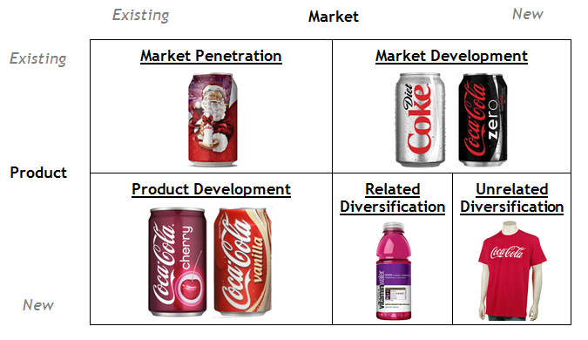

Example:

Watch the two TED talks and summarise in your words the key points and how they may affect the Human Resource department

The four day week: Great management? <https://www.youtube.com/watch?v=xjgqCgoxElw>

Management vs Leadership: <https://www.youtube.com/watch?v=UQrPVmcgJJk>

**Extension task**

Read one of the three books and write a review of no more than two sides of A4of key points:

**Instagram Marketing 2019**: https://www.amazon.co.uk/Instagram-Marketing-2019- Influencer-Advertising/dp/1794524010/ref=pd_sbs_14_4/261-0226356- 2504925?_encoding=UTF8&pd_rd_i=1794524010&pd_rd_r=e80f79e8-65cd-11e9-9e25- d3639f2cda45&pd_rd_w=TtKIt&pd_rd_wg=Q8Vta&pf_rd_p=18edf98b-139a-41ee-bb40- 16 d725dd59d1d3&pf_rd_r=VMNFPCH1B5JX3CV3Y70P&psc=1&refRID=VMNFPCH1B5JX3CV3 Y70P

**Strong Woman, Karen Brady**: https://www.amazon.co.uk/Strong-Woman-Truth-AboutGetting/dp/0007416148/ref=pd_bxgy_2/261-0226356- 2504925?_encoding=UTF8&pd_rd_i=0007416148&pd_rd_r=95c27192-65cd-11e9-b2c0- 9760af0625ea&pd_rd_w=9tJnC&pd_rd_wg=DdAGx&pf_rd_p=07e3e597-b71b-4701-a3fdd79c50f48406&pf_rd_r=WGK8SDYP8YCJP8JC9V5E&psc=1&refRID=WGK8SDYP8YCJP8JC9V 5E

**The 7 Habits of highly effective people, Stephen Covey**: https://www.amazon.co.uk/Habits-Highly-Effective-PeoplePowerful/dp/B002Q0C38Y?ref_=Oct_BSellerC_268290_1&pf_rd_p=8a22af1b-1de0-53d0- bfeb-6e7c6146f4f0&pf_rd_s=merchandised-search6&pf_rd_t=101&pf_rd_i=268290&pf_rd_m=A3P5ROKL5A1OLE&pf_rd_r=5FM91R2W8Z6EA MB8HQKW&pf_rd_r=5FM91R2W8Z6EAMB8HQKW&pf_rd_p=8a22af1b-1de0-53d0-bfeb6e7c6146f4f0