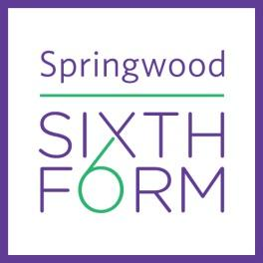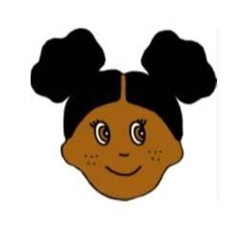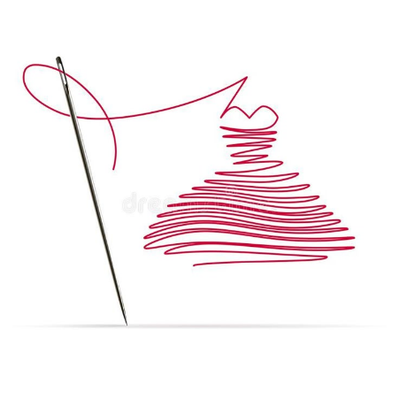

**Summer Tasks Year 13 2025**

**BTEC Level 3 National Extended in Art and Design (Fashion & Textiles).**

**Unit 3: Creative Process GLH 90:**

| **Summer Theme One - Compulsory:**  **Task One Instructions:**  The Creative Process is a Year 13 BTEC unit (which we have already started), this is an exciting opportunity where you are a fashion designer; creating and designing a fashion collection for the Summer Fashion Show As a designer you will need to be inspired and have a starting point for new and original ideas for your fashion collection. *The following tasks will be evidence for unit 3: which will feed into your BTEC (Equivalent to one A Level) portfolio.*  **Fashion Design Illustrations Task One:**   * **Design 3** Fashion Illustrations inspired by the iconic fashion designer **Vivienne Westwood.** * Be creative, consider colour, style, patterns, fabrics and embellishments – inspired by one or more of the famous fashion designers’ themes. * Front view and back view of the fashion illustration designs. * Consider the length of the clothing, pockets, zips etc. Provide close-up drawings of design features. * Draw and use a creative, stylish font for the title page: **Vivienne Weswodd Fashion Designs**. * Annotate the designs, explaining key features about your ideas. Include fabric swatches. * [Makewell with Miss Markwell Pinterest – Vivenne Westwood](https://uk.pinterest.com/emarkwell0561/) - checkout my Pinterest for inspiration on Fashion illustrations *(see examples below on how you can present the work).*   **Suggested Processes / Techniques:** We would like to challenge you to explore a broad range of media when adding colour to your designs, which might include:   * Black outline designs to make them stand-out * Tonal shading with colouring pencils / pens * Mark making * Collage: tear / rip / distress / paper / fabric * Watercolours / paints   Use this opportunity to try out new and inventive ways of capturing your theme; have some fun!  **Summer Task One - Examples:**      **Theme Two (Optional):**  We would like to challenge you to explore and develop your **practical skills** in Textiles.  **Task Two Instructions:**  **Hand Embroidery Sample Task Two (Optional):**   * Create a **hand embroidery sample** using a variety of stitches such as running stitch, backstitch, French knots, etc. Inspired by one of Vivenne Westwood’s fashion designs. * If you are new to sewing check out my YouTube channel [**Makewell with Miss Markwell**](https://www.youtube.com/watch?v=iuz2hDe1FVY&list=PL9lHhz6KzQgryiB4D2QXkAXyaDk4b6FJB&pp=gAQB) for instructional videos. * Equipment: sewing needles, embroidery threads, embroidery hoops (optional), scrap material to sew onto (cotton, felt, old clothes, pillow cases, etc.).   **Summer Task Two Examples:**    **Suggested Additional Instructions/ Reading/ Videos:**  **Key Notes for drawing illustration of the garment:**  Make sure the illustration of the female/male form is in proportion!  Buy a sketchbook- A3 (preferably A3) with ***good quality paper***.  **Buying Fabrics & Sewing Kit:**  The BTEC Art/Fashion course will require you to purchase fabrics, threads, zips and bits & bobs etc.  *as may be required – (The Fent Shop offer a 10% Discount for students on the course).*  [The Fent Shop website link.](https://www.thefentshopkingslynn.co.uk/)  **Purchase your own sewing kit*:*** *dressmaker’s scissors, pins, needles, dressmakers measuring tape, seam ripper etc. The Springwood High School shop sells sewing kits or you can buy your own online or from the shops.*  **Suggested Visit:** A gallery visits - to either a local, national gallery or museum.  **How to sew YouTube channels:**  [**https://www.youtube.com/c/MakewellwithMissMarkwell/videos**](https://www.youtube.com/c/MakewellwithMissMarkwell/videos)  [**https://www.youtube.com/user/ProfessorPincushion**](https://www.youtube.com/user/ProfessorPincushion)  [**https://www.youtube.com/user/MaryCorbet**](https://www.youtube.com/user/MaryCorbet)  **How to design fashion Illustrations:**  [**How to become a Fashion Designer - zoehongteaches**](https://www.youtube.com/@zoehongteaches)  **Art practitioners/ museums/ galleries/ channels:**  [Vincent Van Gogh](https://www.youtube.com/watch?v=3q5fuVFWe0Q)  [Tate Modern](https://www.tate.org.uk/?authuser=1)  [Saatchi Gallery](https://www.saatchigallery.com/?authuser=1)  [V&A Museum](https://www.vam.ac.uk/?srsltid=AfmBOopruZSTnQ_oCNHFBAF-2FGuvawpDiKPONJapWCLkLIMbvn8pHTY)  [Jim Henson](https://www.henson.com/?authuser=1)  [Vivenne Westwood](https://www.viviennewestwood.com/en-gb/homepage/?gad_source=1&gad_campaignid=231123755&gbraid=0AAAAADYSJ9cT4DYvwtpIicvugBqckZpm-&gclid=Cj0KCQjw_JzABhC2ARIsAPe3ynoVPRG1yPUWywReo2DrjQLm3trZSMFaRGqyL1vY-pgWFqSqxvrd7IwaAloXEALw_wcB&gclsrc=aw.ds)  [London Museum](https://www.londonmuseum.org.uk/collections/london-stories/how-mary-quant-revolutionised-1960s-fashion/)  [Alexandre McQueen](https://www.alexandermcqueen.com/en-gb)  **Follow: Makewell with Miss Markwell** on all her Social Media account -: Click on the logo links:  [**My TikTok account**](https://www.tiktok.com/@missmarkwell) **– I follow lots of creative practitioners, might be worth a look…always good to be inspired by other peoples’ work.** |
| --- |