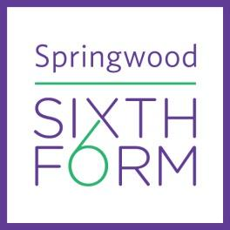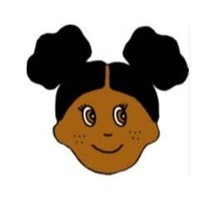

**Summer Tasks Year 12**

**So, you think you would like to study: Fashion & Textiles!**

**The project should largely be contained within an A3 sketchbook (please purchase and use for the summer task and the sketchbook will also be used for a Year 12 project).**

| **Compulsory:**  **Instructions:**  This is your first opportunity to show me your design (art) skills and creativity. I would like you to complete Task One, which will feed into your Year 12 sketchbook/portfolio.  The fashion world takes inspiration from everything – not just fashion designers but from real life, films, literature, music, creative practitioners from ceramicists, photographers etc. For the first task I would like to see how you take inspiration from the Dutch painter Vincent Van Gogh works of art.  **Fashion Design Illustrations Task One:**   * **Design 3** Fashion Illustrations inspired by the Dutch painter **Vincent Van Gogh.** * Be creative, consider colour, style, patterns, fabrics and embellishments – inspired by one or more of the famous artist’s works of art. * Consider the length of the clothing, pockets, zips etc. Provide close-up drawings of design features. * Draw and use a creative, stylish font for the title page: **Vincent Van Gogh Fashion Designs**. * Annotate the designs, explaining key features about your ideas. Include fabric swatches. * Watch the [Vincent Van Gogh YouTube Video](https://www.youtube.com/watch?v=3q5fuVFWe0Q) to inspire ideas for the designs. * [Makewell with Miss Markwell Pinterest – Vincent Van Gogh](https://uk.pinterest.com/emarkwell0561/vincent-van-gogh-fashion/) - checkout my Pinterest for inspiration on Fashion illustrations *(see examples below on how you can present the work).*   **Suggested Processes / Techniques:** We would like to challenge you to explore a broad range of media when adding colour to your designs, which might include:   * Black outline designs to make them stand-out * Tonal shading with colouring pencils / pens * Mark making * Collage: tear / rip / distress / paper / fabric * Watercolours / paints   Use this opportunity to try out new and inventive ways of capturing your theme; have some fun!  **Summer Task - Examples:** |
| --- |